CERTIFIED DEVELOPER FOR KAFKA

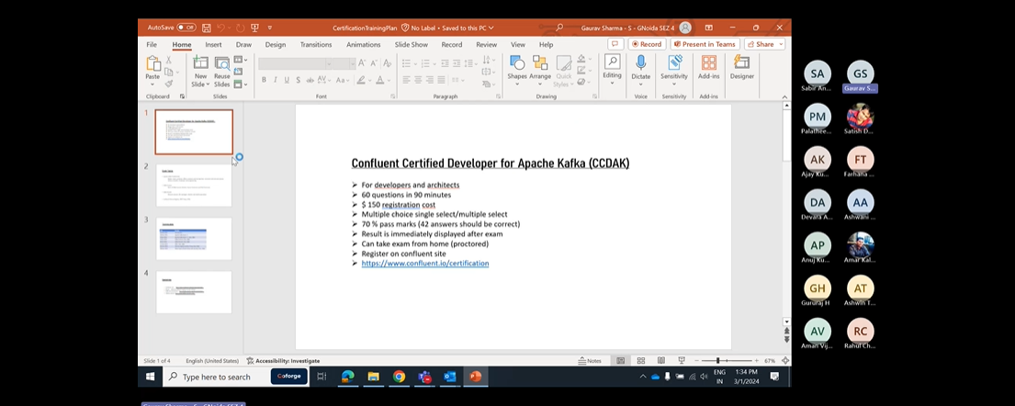

One partition can be consumed by only one consumer with in a consumer group.

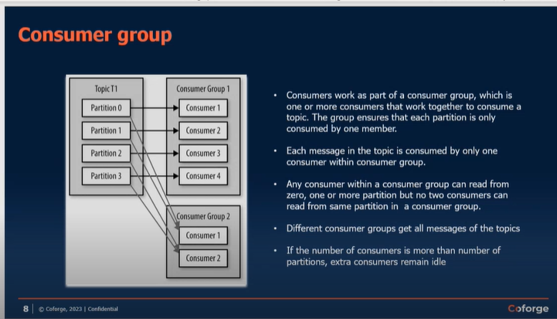

Replication factor in Kafka-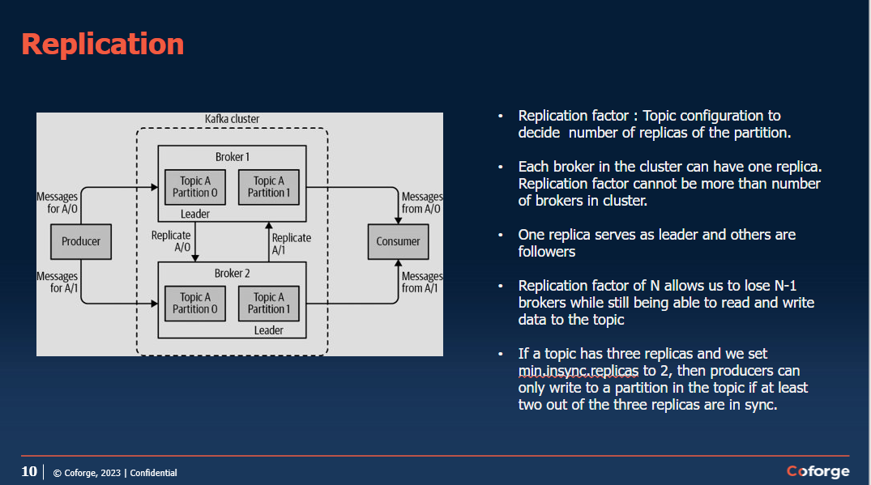

<https://richiebachala.medium.com/11-steps-for-understanding-confluent-kafka-for-data-engineers-47ab9a398bed>

go through for kafka confluent cluster details.

Zookepers are always odd numbered in Kafka Cluster.for normal organisation count is 3 and for very large organisation count can be 5.

# REST Proxy-

It is used to expose API to expose rest end point to external API’s. we cannot give access directly external applications for the kafka cluster.

Rest proxy so rest proxy is basically it will just provide the rest API OK and when the applications invoke that those rest API's they can post the messages to Kafka broker or they can just read from Kafka broker. So those kind of features that we provide rest proxy.

OK, so they don't have to connect to the Kafka broker, they can just directly put it to this API and internally this rest proxy will send it to the desired topic. OK we I will see this in details in next sessions

# Confluent KSQL-

When you want to copy some data from the topic and paste it to another topic via queries. It is done

With the help of KSQl.

Go through these things at-<https://richiebachala.medium.com/11-steps-for-understanding-confluent-kafka-for-data-engineers-47ab9a398bed>

Kafka Connect-

Kafka Streams App-

Microservice-

Confluent Control Center-

· Web based tool for managing and monitoring data pipelines and streaming applications on Apache Kafka.

· Data Stream Monitoring and Alerting using drill-down from Producer to Consumer.

· Multi-cluster monitoring and management data replication between clusters.

· Kafka Connect Configuration to add new sources to load external data systems.

· Runs on a single dedicated machine.

What is the use of Schema Registry-

Schema Registry is in the Avro format i.e. it will have data type and variable.in json we do not have any data types.

OK. Again, it depends on the producing and consuming applications which schema registry like if they want to use schema registry or not. OK suppose you serialise your message so whenever you create a record OK and you want to send it to Kafka so there are two things you need to do. One is you need to make sure that it is in proper format. OK so that consuming application can do. Second thing is you you need the Kafka has to convert it to.

A stream of bytes. OK, serialise it. OK, so you need to mention the configuration property, key serializer and value serializers. OK. There you will mention Avro and you need to give the schema registry URL. So that means it will be serialised according to your Avro schema. Whatever you have mentioned in the schema registry. OK.

Use of brokers-

* The broker receives messages from producers, assigns offsets to them, and writes the messages to storage on disk.

Controller is selected by a zookeeper.

* The controller is responsible for administrative operations, including assigning partitions to brokers and monitoring for broker failures.
* A partition is owned by a single broker in the cluster, and that broker is called the leader of the partition. Replicated partition is assigned to additional brokers, called followers of the partition

All producers must connect to the leader to publish messages, but consumers may fetch from either the leader or one of the followers.

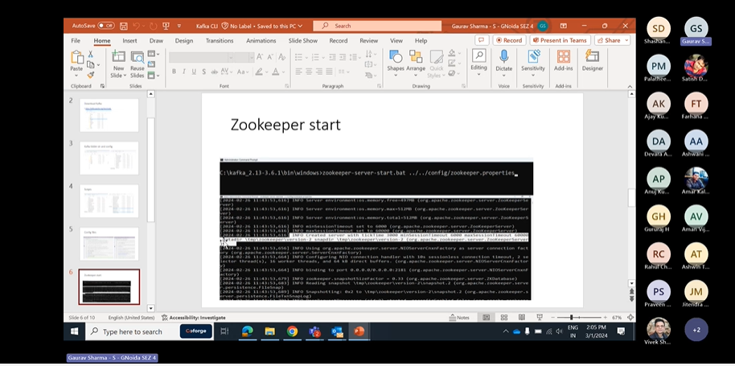

Zookeeper can be started anytime with the properties configured.

* Zookeeper cluster is called ensemble.
* Odd number of servers (typically 3 or 5)
* All servers need to have common configuration file
* Quorum : majority of the servers should be running to form a quorum Q=2N+1
* Configurations:
  + tickTime:2000
  + dataDir:/var/lib/zookeeper
  + clientPort:2181
  + Server1 : hostname: peerPort: leaderPort
  + Server2
  + Server3
  + initTime : the amount of time to allow followers to connect
  + syncLimit : value limits how long out-of-sync followers can be with the leader.

# Cluster membership

* Each broker has a numeric broker id , mentioned in the config file.
* Broker registers itself with the zookeeper using this id creating ephemeral node
* Each broker in a cluster has unique id
* The first broker to register itself with the zookeeper becomes controller.
* If controller goes down, other brokers attempt to become controller
* Controller helps in selecting leader partitions.
* Zookeeper selects controller and stores metadata (brokers, topics, partition, replicas)

# Partition allocation

* Assume 4 brokers, new topic with 4 partitions and a replication factor of 3

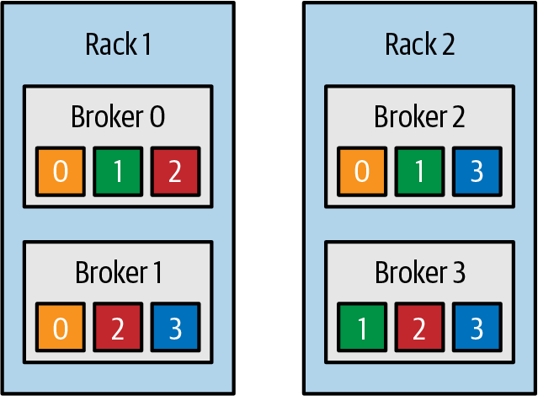

Topic is divided into partitions, partition is divided into segments for the purpose of writing data to the disk. Segment file can be retained for time duration or based size limit.

Active segment is not deleted.

If fewer messages are expected, retention should be maintained on time basis

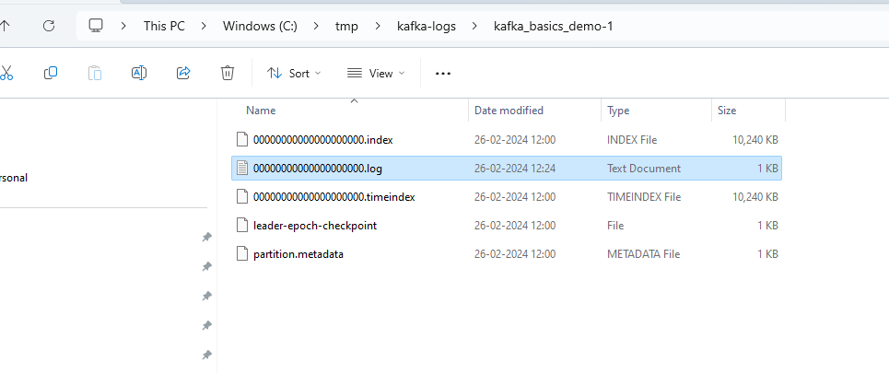

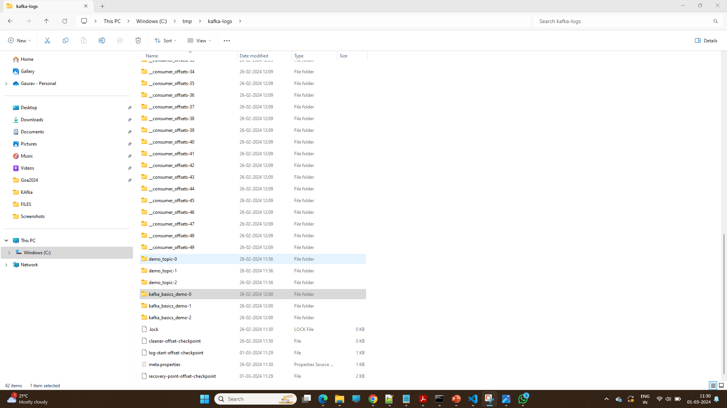

In kafka Topic is divided into partitions, partition is divided into segments for the purpose of writing data to the disk. Data is stored in the form of segments once the segment is complete to specific space.it will create another segments to store the data.

If producer is slow ,we can configure it will create another topic after specific time interval.

# KAFKA Producer-

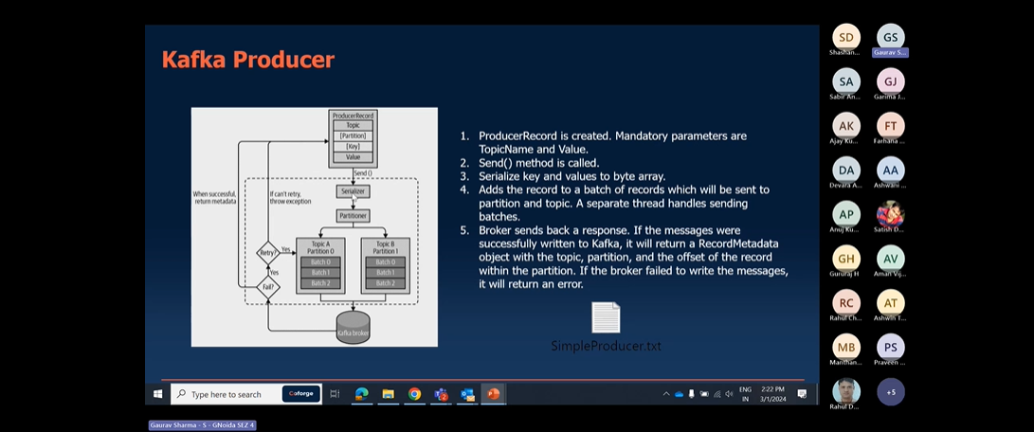

Retry Mechanisms-

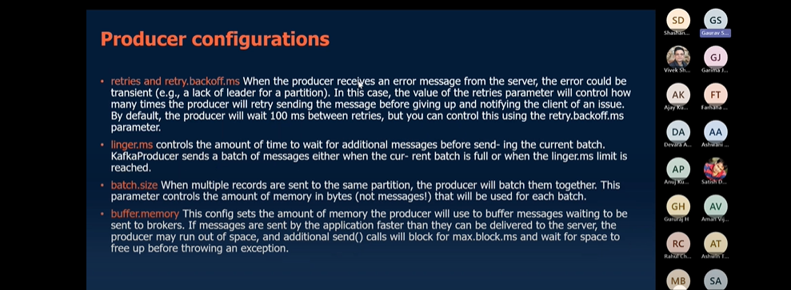

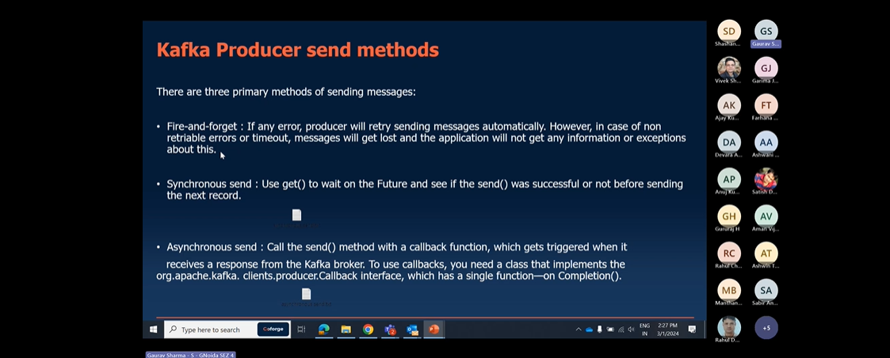

Fire-forget🡪send msg and forget ,if data lost it is not observed by our app.

Synchronous send🡪single thread mechanism it will wait until the acknowlwdgement received from kafka.

Asynchronous send🡪multithreaded mechanism , one thread will pass by and another thread will wait for Acknowledgement.

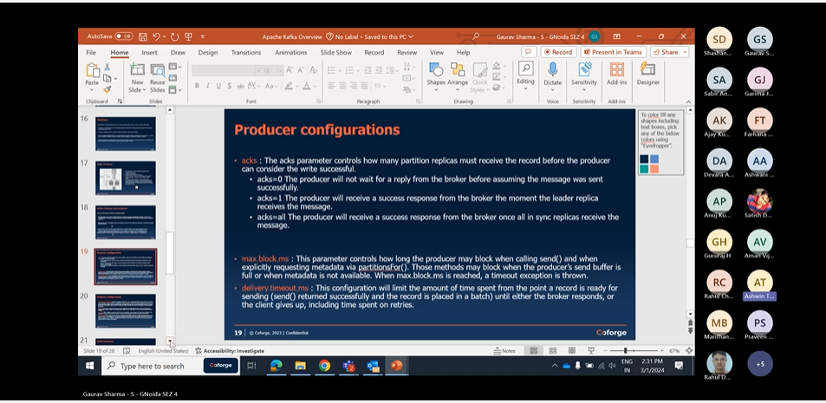

“Not Enough Replica”-

Like as if we want replica to backup. and we have Replication factor:4 and minimum insync replicas :3 and we have two of our broker down ,so it will not be possible for us to get acknowledgement giving “ “Not Enough Replica” error.

reduce value:”insync replicas “ .it will work

# Producer Configurations

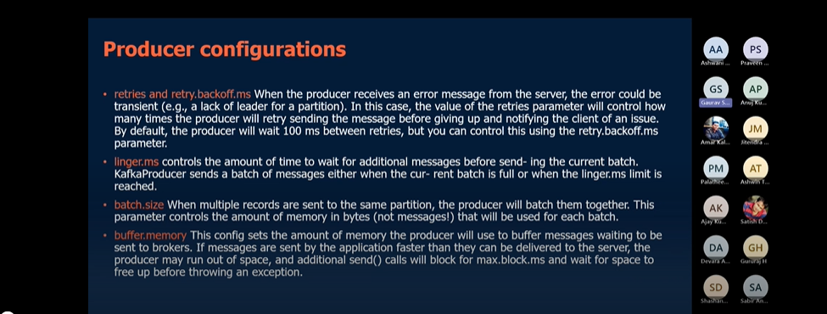

Retry.backoff.ms🡪time between each retry.

**Linger.ms**🡪sometimes the producer is too slow and the producer will wait for this much time only before pushing messages to kafka.if this much time is passed it will push the messages.

**Batch size**🡪if your producer is fast than you can increase the batch size and you can push messages at faster rate.

Kafka Consumer:-follow multiple configurations , without which it will not start the kafka Consumer.

BootstrapServers

Key.deserializer

Value.deserializer

Kafka Consumer have following properties-:

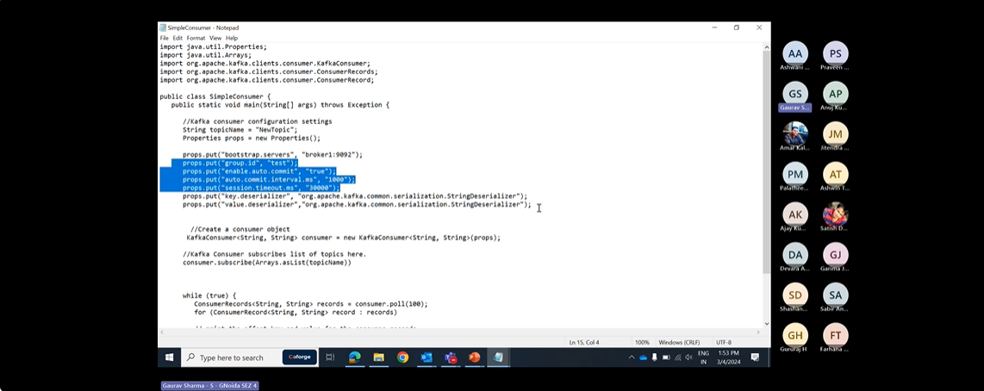

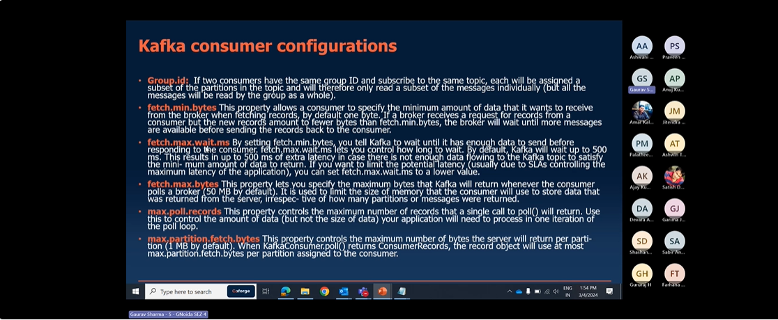

Fetch.min.bytes:-by default it is 1 byte.if a broker gets request,but a new records amount less than fetch.min.bytes.broker will wait for for more Records before sending.

Fetch.max.wait.ms-since the broker waits for records to come because of fetch.min.bytes it increase the lag.by default wait time is 500 ms .we can reduce it as per our wish.

Fetch.max.bytes-it specifies the maximum bytes that kafka will return whenever consumer polls a broker.it is used to limit the size of a memory that consumer will use to store the data that was returned from server.

Max.partition.fetch.bytes-it specifies the maximum number of bytes server return per partition.

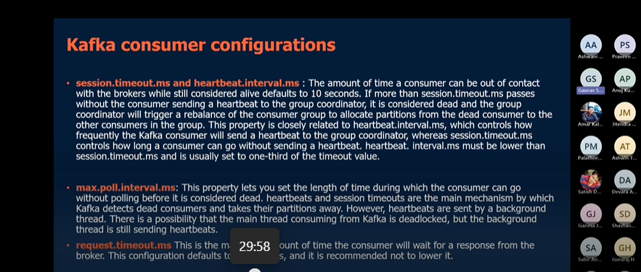

Session.timeout.ms -The amount of time a consumer can be out of contact with brokers while still alive defaults to 10 seconds. if more than session.timeout.ms passes without the consumer sending a heartbeat to group coordinator,it is considerd dead and the group group coordinator will trigger a rebalance of a consumer group to allocate partitions from dead consumer to other consumers.

heartbeat.interval.ms -it controls how frequently kafka consumer will send heartbeat to group coordinator.

Generally Session.timeout.ms and heartbeat.interval.ms are closely related to each other. Session.timeout.ms basically defines the time in which consumer can go without heartbeat.it is generally Session.timeout.ms set to 3 times heartbeat.interval.ms

Max.poll.interval.ms-

Lets you set the length of time during which consumer can go without polling before it is considerd dead. Heartbeat and Session timeout are the main mechanisms by which kafka detects the dead consumer and takes their partition away.and there can be scenarios in which main thread is deadlocked and background thread is sending heartbeats.

Request.timeout.ms:-maximum amount of time consumer will wait for response from broker. The

Configuration defaults to 30 s.it is recommended to lower it.

Auto.offset.reset-it controls the behavior of consumer when it starts reading a partition which doesnot have commited offset or if the offset it has commited is invalid.

Earliest:means it starts reading from earliest offset

Latest: means it starts reading from the latest offset or new available offset

None: if we set it to none .it will automatically give an exception and consumer will be stopped automatically.

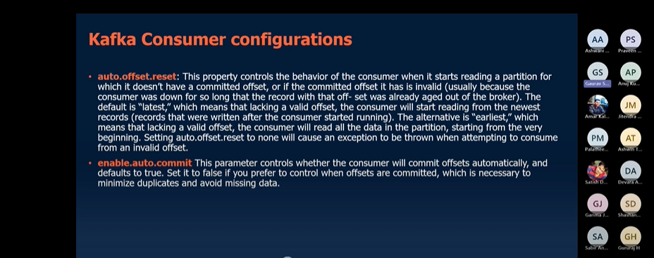

Enable.auto.commit: -either you will commit automatically or you will commit manually within code.

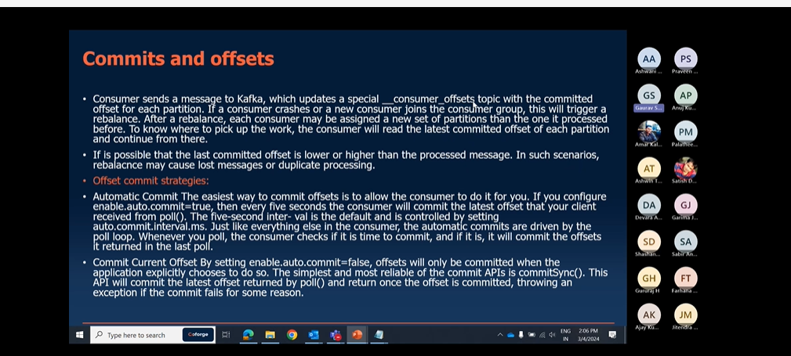

CommitSync-means you are Synchronously commiting the offset.In this we have risk of losing the records i.e commiting the records before processing.

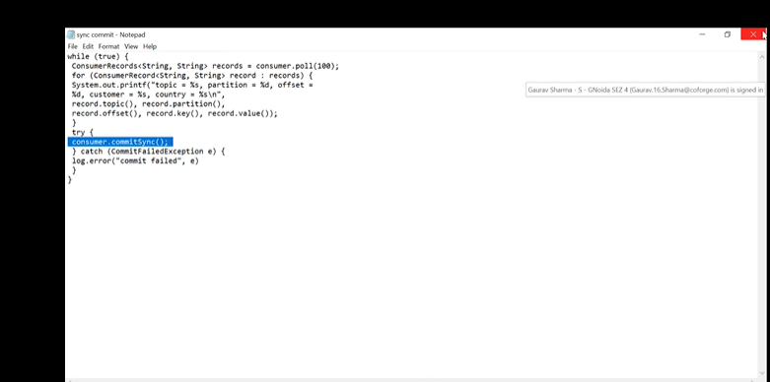

Asynchronous Commit-: one drawback of manual commit is that application is blocked until the broker responds to commit request.This will limit throughput of the application.Throughput can be improved by commiting less frequently.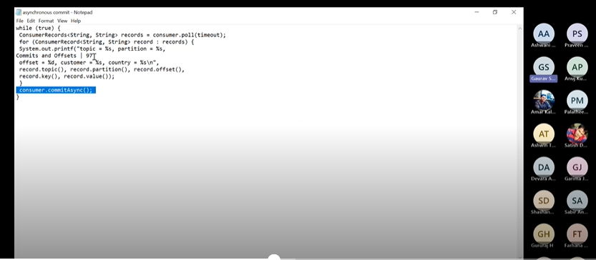

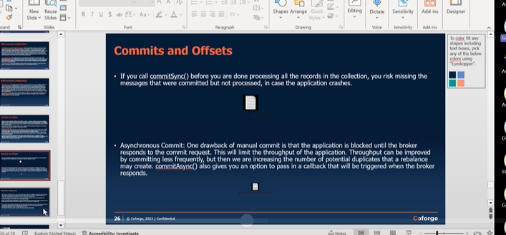

Rebalance:-

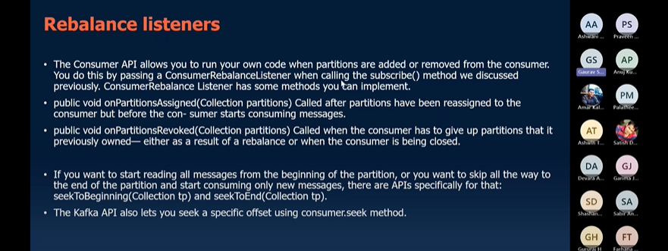

# KAFKA CONNECT-

It is Another way to push data to kafka and push data from kafka to external sources.Kafka connect provide connect Api which provide easy to use configuration in kafka. There are multiple libraries that multiple developers have written.which are very easy to use.

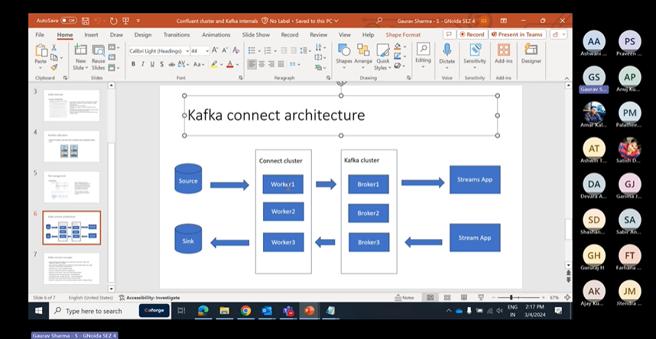

OK, So what happens is there are many libraries which many developers have written K both open source as well as confident libraries which are like very easy to use.

And this connect API right there is an API provided by Kafka which is called **Connect API**.

This provides an easy to use configurations like.

We can just configure to use one of those libraries, OK and it will start.

It will start the JVM and it will start getting messages in two Kafka from external sources or from Kafka to external data syncs.

OK, so there are two kinds of connectors.

We can create one is source connector which will receive data from outside to Kafka and sync connectors which will just push messages from Kafka to outside.

Data syncs.

OK.

So two kind of connectors we have.

OK, this is how the connect architecture looks like.

So we have the Kafka cluster, we have the brokers here and for connect connect cluster for a connectors we can have another cluster like we can have many other servers which are which where we can run this connect and we these will have the same group ID's OK like for Kafka cluster we were using a broker idea Broker 0 Broker 1 broker 2 like that here also we have a similar kind of configuration.

We can have multiple servers where we can run this, connect multiple nodes and these will work together to distribute the load and create the task for source and sink connectors.

OK, so these are called workers.

OK, Kafka connect cluster is there and I'll just show you how to start it

Working of kafka connector-

Config-

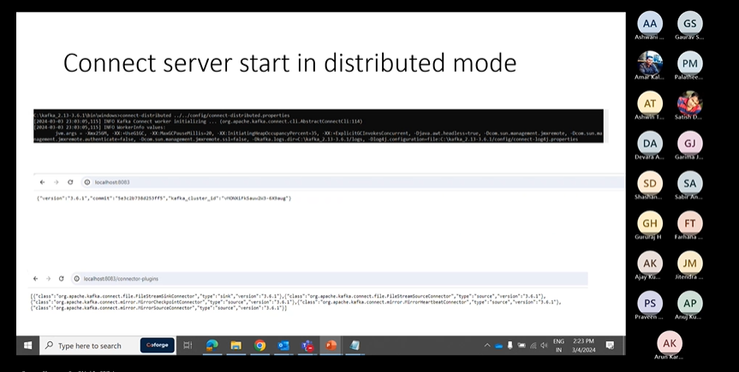

OK, I just created one file topic, the topic where I want to put the content, OK and then I've given the you are like this one.

OK, this is the API I'm calling local city.

It is collectors.

OK, then it creates the connector.

OK, this is the file I've shown input file where it has a I just written 3 lines here OK and once the connector is created it will start pushing the content to this topic.

OK, I'll started a console consumer here and you can see it comes in the JSON format.

It's coming like this.

Payload uh is your first message.

Secondly, from the file it it just yeah, uh pulls it to Kafka.

OK.

And if I go to this API connect us, I can see there is one connector here now.

OK, so Kafka input.

This is the one which I just created here.

So is demographically OK, and if I want to see the configuration I can just go to this connector.

I just check the URL connector slash so semeka input and I will see the details like what is this connector, the connector classes here file is here.

Name, topic.

Everything is here, OK?

And to check the status I can just put the status here.

OK, status done.

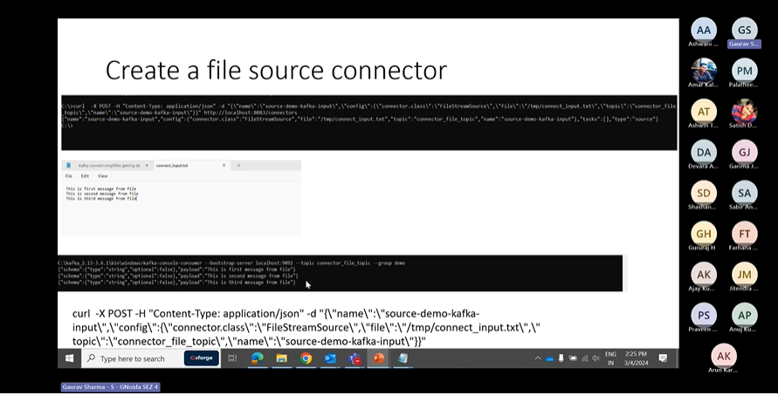

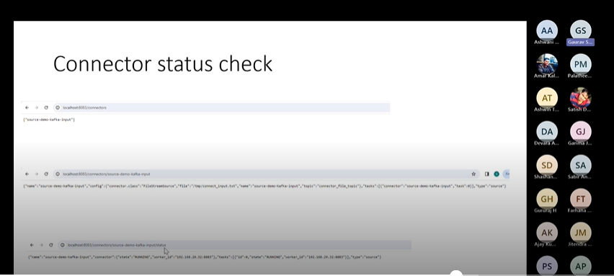

Delete Connectors-

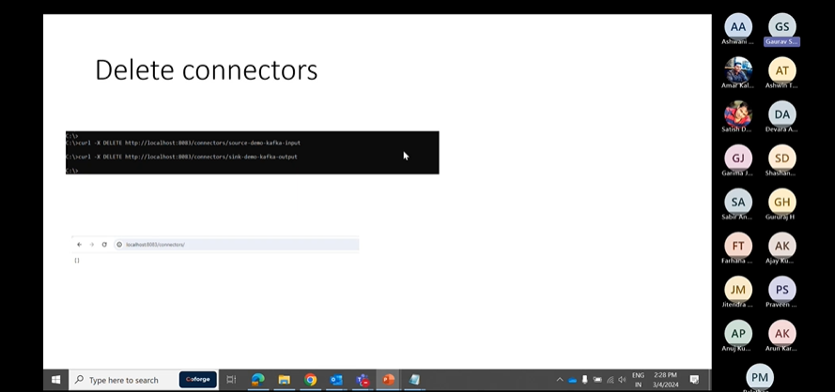

QUIZ

Q1)

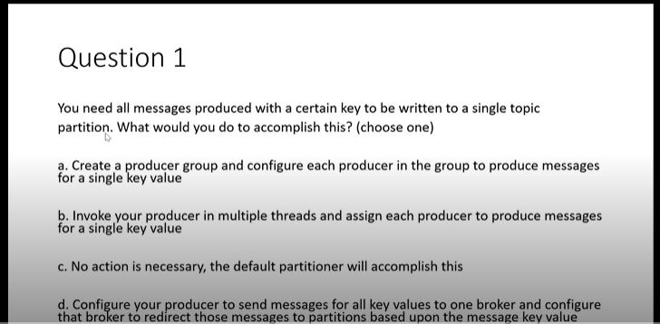

c.)because kafka stores the data in the form of hashing. It will store the data specific to partition automatically.

Q2)

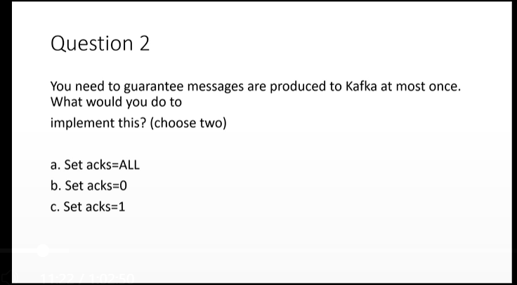

b),c) since acks=0 we would not get any responses from Replica.it is like fire and forget.

Acks=1 we would get Responses from replica at least once.

Acks=ALL mean we would be waiting for responses from multiple replicas.

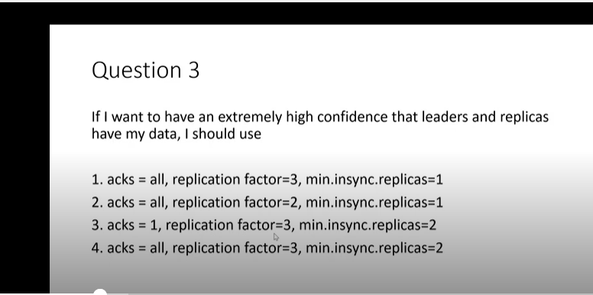

4)most reliable

Q4)

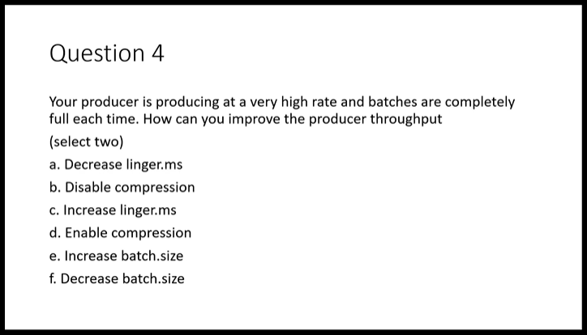

a),e)linger.ms it is the max time producer wait before pushing batch to kafka.

batch.size-it is size of batch to be pushed to kafka.

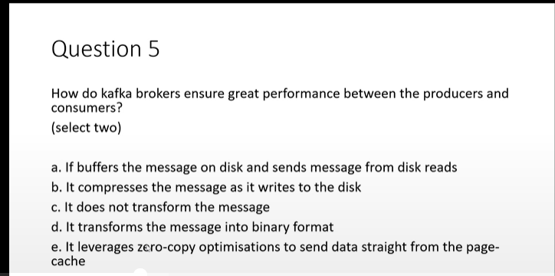

Q5)c),e) kafka does not transform the messages producers and consumers automatically serialize and deserialize the messages.

e)as if we can send messages directly to consumers.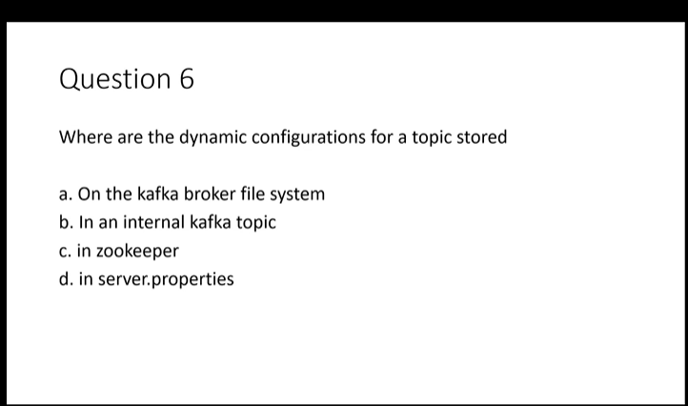

b) configurations are stored in internal kafka topic.zookeper just manages leader and metadata other stuff.

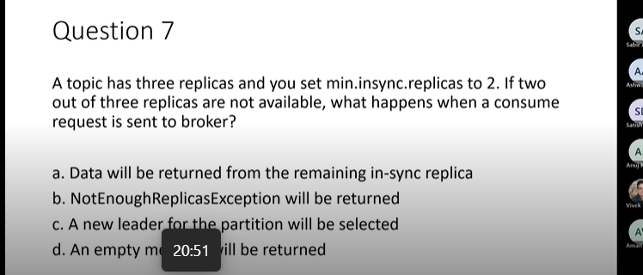

b)

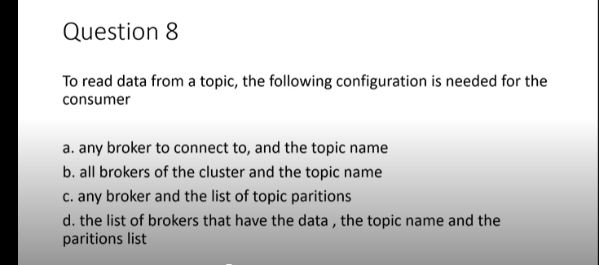

a)only one broker is enough to connect to a particular topic.we give list of broker if a particular broker is not available so it can check other brokers.

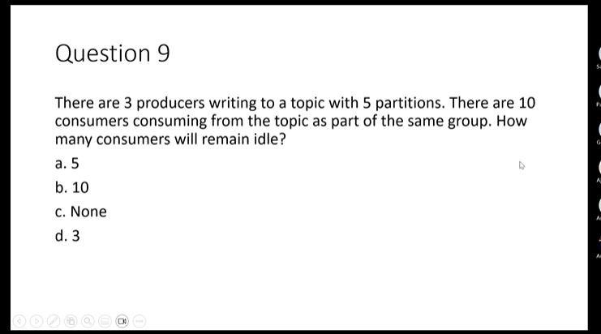

a)since only one consumer will consume at max from a particular partition. Remaining consumers will remain idle in such scenarios.

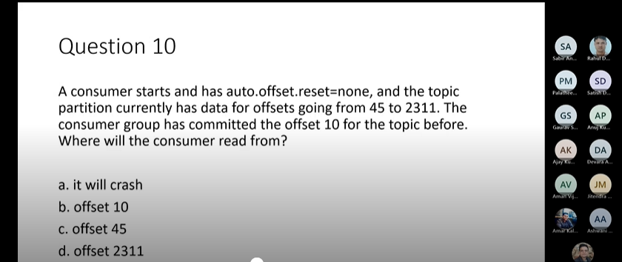

a)it will crash ,as will search next offset i.e 11 which it will not find.

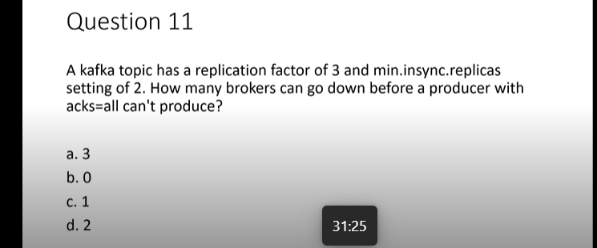

c) 3 brokers 2 must be in sync one can go down.

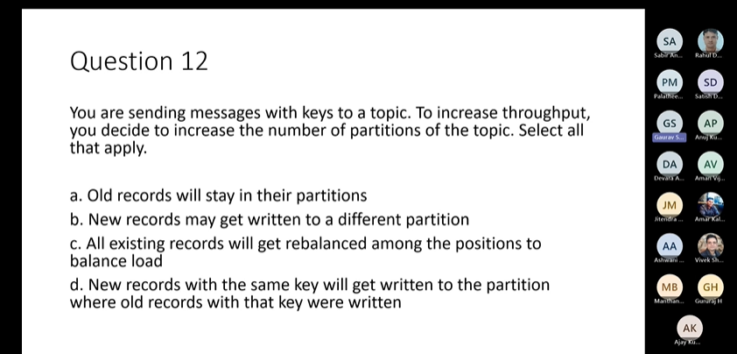2

a),b)

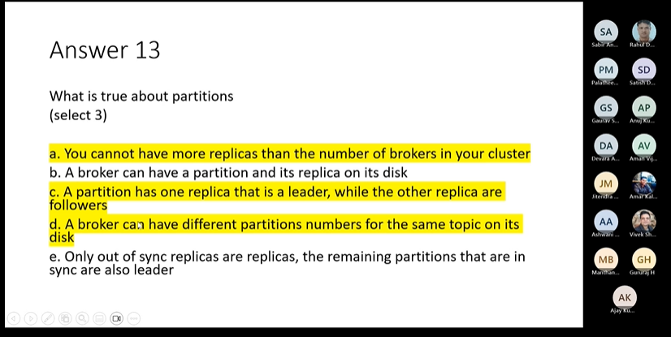

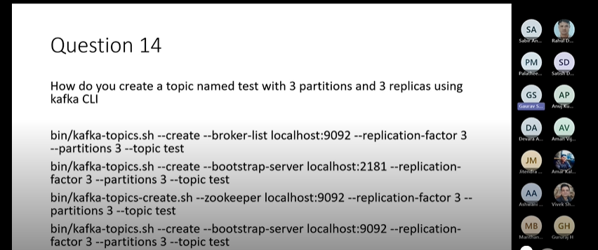

4)

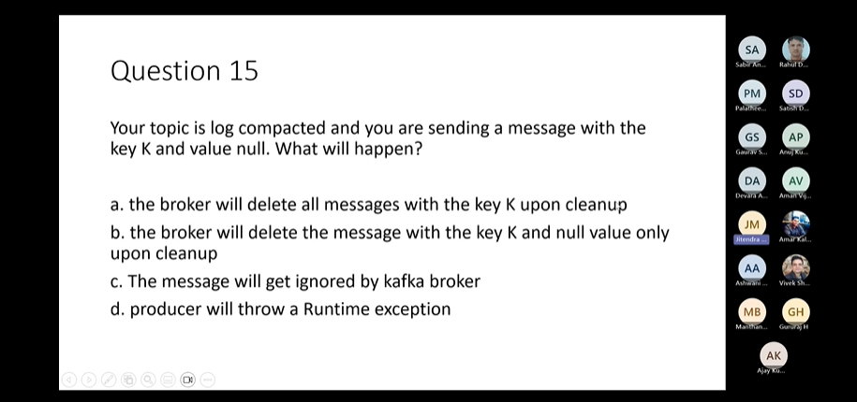

a

KAFKA STREAM CONCEPTS-

Kafka Schema Registry:-

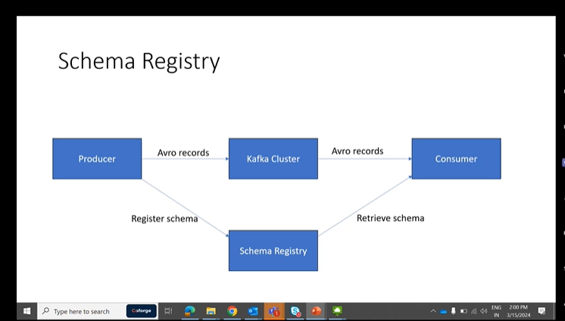

When Producer want to send message through kafka so message must be as per schema. Producer is producing the records and Consumer is consuming the records if producer will send the record along with schema, the record will be very heavy.

So what it what it does is it can register the schema and schema registry OK and when it registers it will get an ID OK scheme ID.

Can send that ID in all the messages, OK consumer when it gets the messages that will use that ID to retrieve the schema and it will deserialize and read that message. OK, so this is the idea about schema registry.

Yeah, simple idea. Could be subclass the record, serialises the record using every serializer, adds a schema ID consumer will use that every deserializer and schema schema ID to deserialize the record.

OK, so these are the services schema history is providing. It allows the producer and consumers to communicate what are well defined data contract in the form of schema. Then it is facilitating the communication by storing the schema. OK, it controls schema evaluation with clear and explicit compatibility rules. So what does it mean? It means that suppose today we have a schema, we have 10 fields OK and producer and consumer set up using that schema for communication.

Tomorrow there is a business requirement to add one more field. OK, so that will be stored as next version of the schema. OK Version 2 and we have certain set of rules like it should be backward compatible or forward compatible. We'll discuss those in details. So according to that the schema registry will accept the new schema or it will reject it. OK, if it doesn't fit with the rules it will reject it. So why? Why that happened? Because the production should not break the communication should not break.

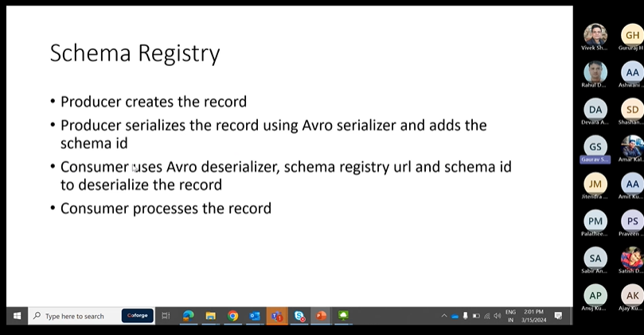

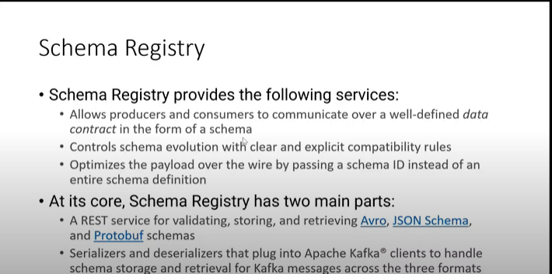

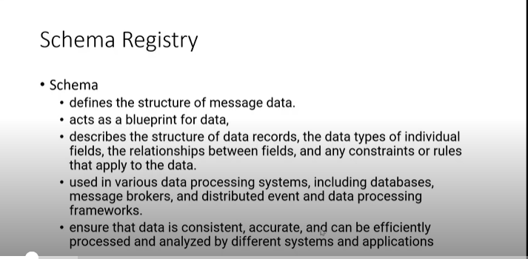

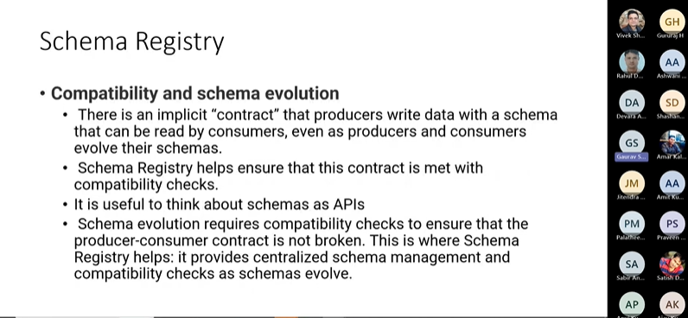

**Data Serialization** means process of converting data structures or objects into format that can be transmitted across a network.

Confluent Schema Registry supports AVRO,Json Schema Serializers and Deserializers(serdes).

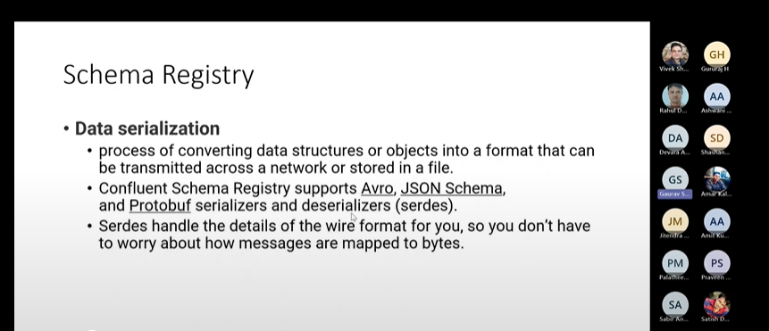

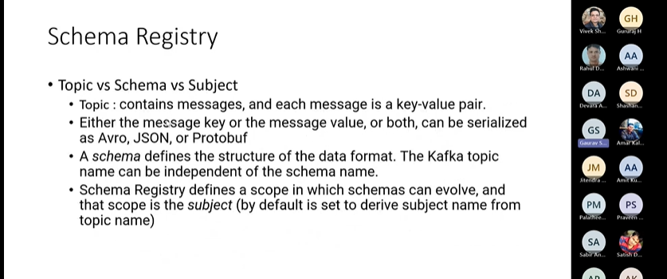

If we want to put a change in schema ,the version of a schema must be upgraded.

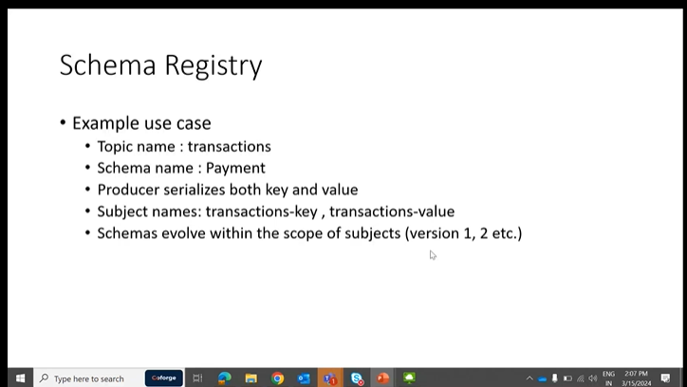

How to get latest Schema and values.

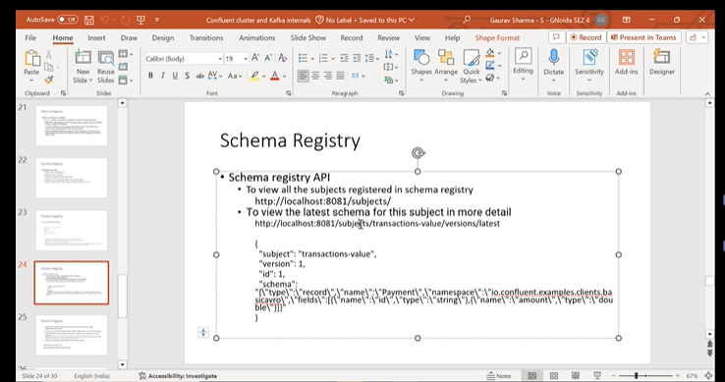

Schema Registry:-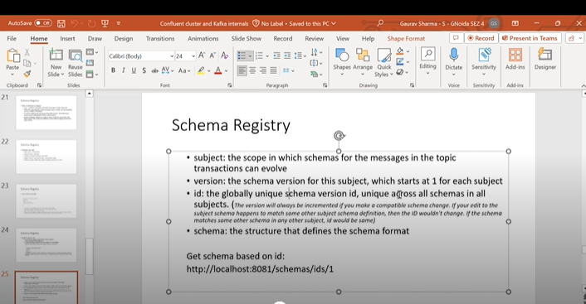

In schema registry the Schema ID’s are generated. if there is any change in Schema, a new version of the Schema will be generated automatically. If any other subject is using a particular schema then it will generate same id of that schema in a subject.

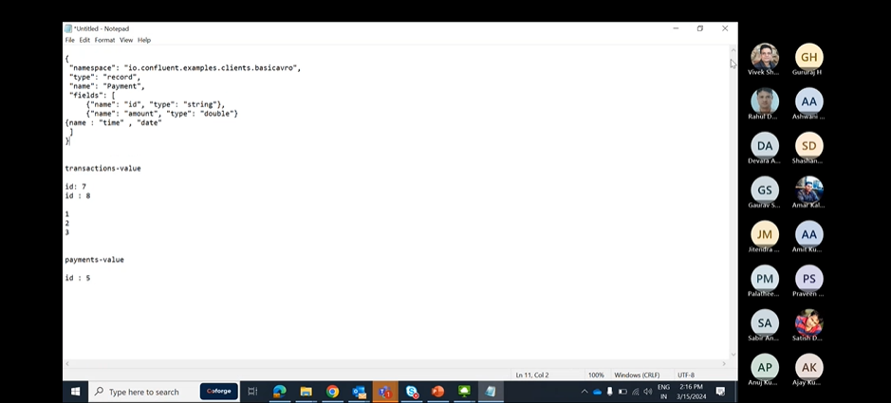

We generally get the schemas using subject and Schema and we can get the schemas using Id’s as well.

:8081/schemas/ids/64

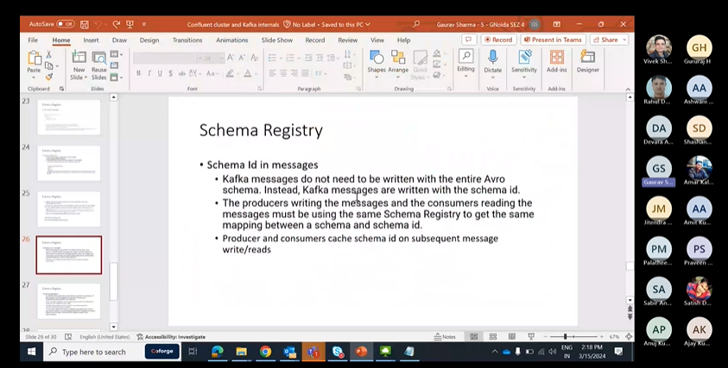

Schema Registeration:-

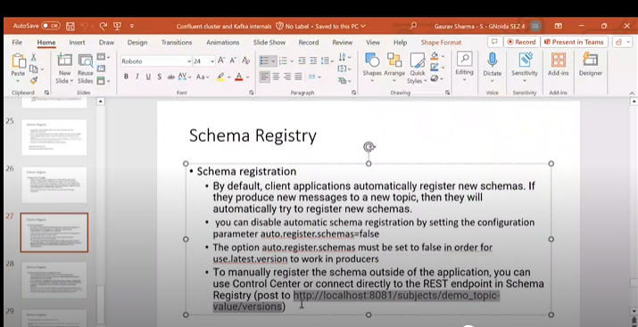

Schema Registry Compatibilty

BackwarD: Consumers using V3 can read the data written by producers using V2 Schema.

Backward\_Transitive:-Consumers using V3 can read data written by producers using Previously Registerd Schemas(V1,V2).

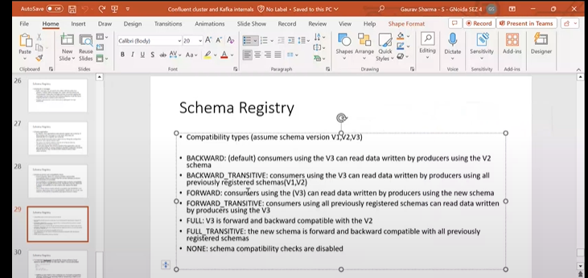

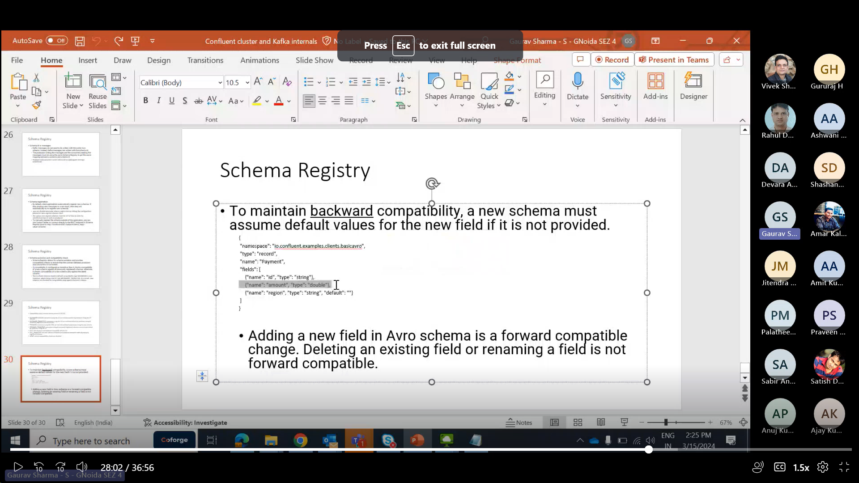

In the example above it is backward compatible as producer is using old schema and do not sends the new region field as per new schema, so it will not cause issue as region is set to default.it will ignore.

If you change anything with the Schema i.e amount ,it will not pick up and probably give serialization errors.

You can go through this page for better understanding:- https://docs.confluent.io/platform/current/schema-registry/index.html

KSQLDB-https://docs.ksqldb.io/en/latest/developer-guide/ksqldb-reference/

Q)ONE of the four core ApI’s of Kafka-

Admin API

Q)For Kafka,what is proper value of heap size?

6GB

Q)false statement for Zookeper znodes?

zNodes can be renamed through CLI. sc

Q)Which consumer becomes the group leader of a consumer application?

First consumer to join the group.

Q)Replication factor=3,min.insync.replicas=2,acks=all which exception is thrown?

Exception:NOT\_ENOUGH\_Repicas

Q)which Network Protocol is used by Kafka to achieve high performance?

TCP

Q)Fetch rate is high and each fetch is small.How to maintain throughput?

Increase fetch.min.bytes.

Q)After a forward schema evolution,which order of upgrading producer and consumer clients should you prefer?

Upgrade producer first.

| **Compatibility Type** | **Changes allowed** | **Check against which schemas** | **Upgrade first** |
| --- | --- | --- | --- |
| BACKWARD | * Delete fields * Add optional fields | Last version | Consumers |
| BACKWARD\_TRANSITIVE | * Delete fields * Add optional fields | All previous versions | Consumers |
| FORWARD | * Add fields * Delete optional fields | Last version | Producers |
| FORWARD\_TRANSITIVE | * Add fields * Delete optional fields | All previous versions | Producers |
| FULL | * Add optional fields * Delete optional fields | Last version | Any order |
| FULL\_TRANSITIVE | * Add optional fields * Delete optional fields | All previous versions | Any order |
| NONE | * All changes are accepted | Compatibility checking disabled | Depends |

**In forward schema validation the fields are added,even if we add upgrade consumer first we will not get the data as producer is unable to produce with added field,so better upgrade producer first only**.

**In Backward schema validation few fields are deleted so to avoid any invalid data now in consumer with additional fields consumer first.**

FORWARD compatibility means that data produced with a new schema can be read by consumers using the last schema, even though they may not be able to use the full capabilities of the new schema.

BACKWARD compatibility means that consumers using the new schema can read data produced with the last schema. For example, if there are three schemas for a subject that change in order X-2, X-1, and X then BACKWARD compatibility ensures that consumers using the new schema X can process data written by producers using schema X or X-1, but not necessarily X-2

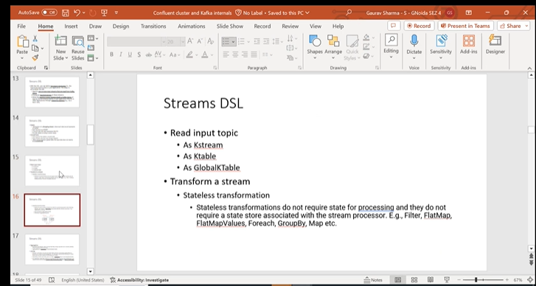Stateless transformations do not require state for processing and they do not require a state store associated with the stream processor. Kafka 0.11.0 and later allows you to materialize the result from a stateless KTable transformation. This allows the result to be queried through [interactive queries](https://kafka.apache.org/20/documentation/streams/developer-guide/interactive-queries.html#streams-developer-guide-interactive-queries).

Stateful Transformations:-

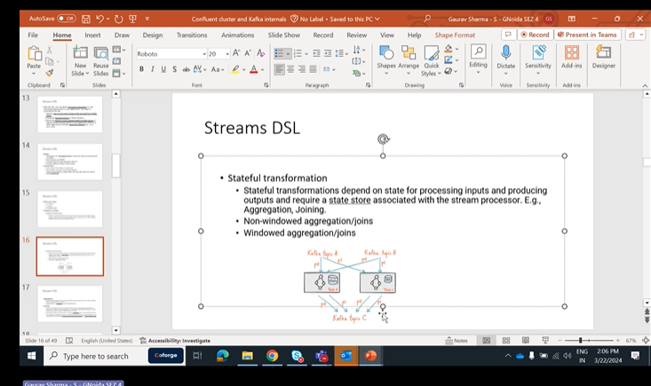

### [Stateful transformations](https://kafka.apache.org/20/documentation/streams/developer-guide/dsl-api.html#id11)

Stateful transformations depend on state for processing inputs and producing outputs and require a [state store](https://kafka.apache.org/20/documentation/streams/architecture.html#streams_architecture_state) associated with the stream processor. For example, in aggregating operations, a windowing state store is used to collect the latest aggregation results per window. In join operations, a windowing state store is used to collect all of the records received so far within the defined window boundary.

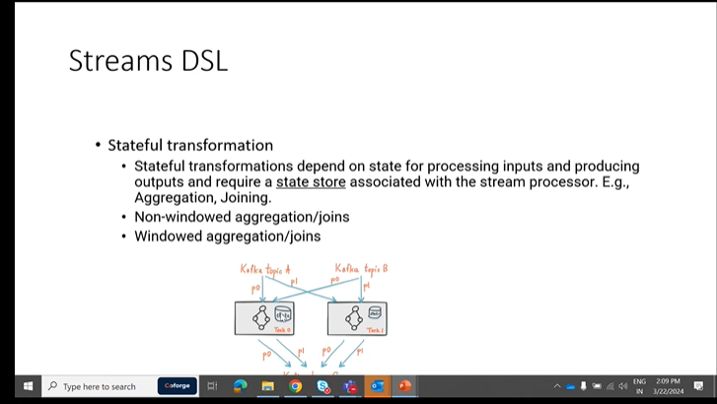

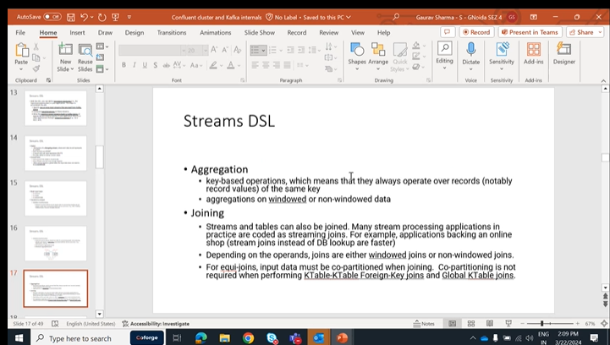

 That is, scenarios where you need to perform table lookups at very large scale and with a low processing latency. Here, a popular pattern is to make the information in the databases available in Kafka through so-called change data capture.

| **Join operands** | **Type** | **(INNER) JOIN** | **LEFT JOIN** | **OUTER JOIN** |
| --- | --- | --- | --- | --- |
| KStream-to-KStream | Windowed | Supported | Supported | Supported |
| KTable-to-KTable | Non-windowed | Supported | Supported | Supported |
| KStream-to-KTable | Non-windowed | Supported | Supported | Not Supported |
| KStream-to-GlobalKTable | Non-windowed | Supported | Supported | Not Supported |
| KTable-to-GlobalKTable | N/A | Not Supported | Not Supported | Not Supported |

KStreams is an important topic,need to go through it.

[https://kafka.apache.org/20/documentation/streams/developer-guide/dsl-api.html#streams-developer-guide-dsl-joins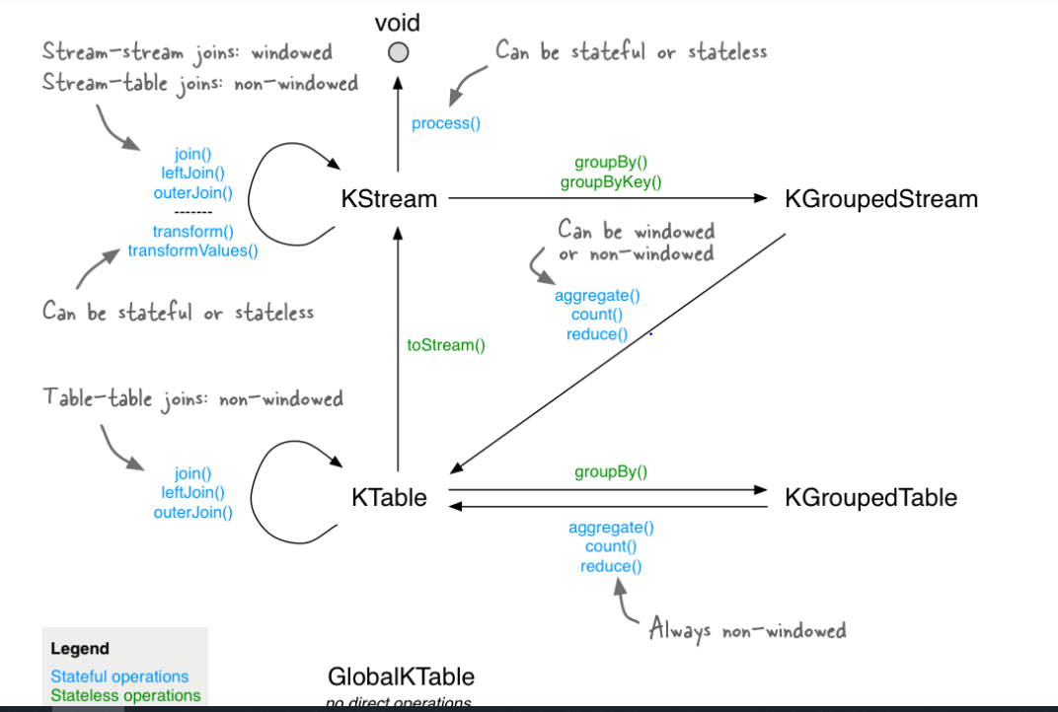](https://kafka.apache.org/20/documentation/streams/developer-guide/dsl-api.html#streams-developer-guide-dsl-joins)

Straightness operations K stream to K Stream joins are stateful operations. Case stream to K Stream joins straight full operations because K streams are continuous unbounded data set. So we need to define some kind of window to to a join. OK, so this is windowed join and stateful join OK.

And then we have a.

K Table Table Table joins this. Those are known nonindowed joins. OK, so those are also stateful operation but they are not windowed. So that means we don't because K table is static like it's just maintaining the latest value of the keys. OK so we don't have to. It is nonwindow like we can do the join at a time. We can do it over complete K table. We don't have to define the windows OK.

Then we have a we can convert K table to K string which is a stateless operation to string. So these kind of things are given. You can just read it and go through the documentation. We understand it.

So this is the important thing Windows. What kind of windows are available to us? OK, to do the operations and this go back to this one.

The windowing part.

Yeah. So we're doing, let's control how to group records that are the same key for stateful operations such as aggregations or joins into Windows. OK for record key, let's say.

Do you want to do a count over last five minutes? OK, with the hopping window, that means every one minute the window will change. So here if you see green coloured, let's say green coloured is key one, OK and you are just doing the aggregation 0 to 5, zero to 5 minutes. OK so as soon as one minute passes.

Your window becomes 126 OK.

SMS second passes your operation. Your window becomes 227. OK, so this is hopping like one. One minute hop is there OK and five minutes is the window time. OK, so this way you're doing the aggregation so in colour is key. Once blue coloured is another key. OK, so you can see how it is changing.

It's this is hopping window.

Then you have tumbling window tumbling Windows Zero to five. You have some kind of you have the window zero to five minutes and after 5 minutes have passed another window starts 5 to 10 minutes. OK. So for 5 minutes the state remains the same. The Count will remain the same for 1st 5 minutes or whatever window duration you are given and as soon as that duration is passed again another state will start like another aggregation will start OK 5 to 10 minutes.

OK, this aggregation will happen after the duration pass. Another aggregation will happen. So this way it will happen OK states to like will be there for 5 minutes. After that again another one will start, another window will start.

This is doubling window.

Landing window it's it's same as the hopping window, but the window the the hop like there one minute hop right? But here it is very small like 5 milliseconds so it it almost slides like it's just.

Sliding over within 55 milliseconds, the window is changing OK and also there is one more concept here. It will work on difference between record time stamp so it will just calculate the difference between 2 records and if it is less than five. If it is more than five milliseconds do you just add it in the in this one?

It in the the aggregation or whatever population here does.

Sliding window and hopping window are almost the same actually, except that here the the gap duration is very small so it looks like a continuous slide.And we have session Windows session windows means the session is created OK and if let's say we are getting the keys here P1 is received at first minute, first, zeroth, minute.

And then we have another.

Kiat 60 minutes and we say session window 5 minutes gap. So if for the first five for the five minutes after receiving this we are not getting anything. So that means it's an, it's a gap of inactivity. So there is no event with that same key is received. That means we'll start a new aggregation. After that we'll not, we'll just discard it. OK. If there is a gap of five minutes. So this is what happens when the customer calls in, right?

There's a gap of inactivity. It's not doing anything a session time so. So similarly, there is a time out, five minutes. OK. And what's that? 5 minutes is passed between this timeout and start a new session. After that, whenever the new event is received and that session will start from this one OK. And if there is a inactivity of five minutes, it will just again timeout. But let's say if we are getting more events here before the five minutes have expired so session will continue.

Gaurav Sharma - S - GNoida SEZ 4 27 minutes 28 seconds

OK, session will continue. OK. I need to just keep on adding or aggregating the events, OK.

Gaurav Sharma - S - GNoida SEZ 4 27 minutes 37 seconds

That that is session windows.

Gaurav Sharma - S - GNoida SEZ 4 27 minutes 40 seconds

So these these are three four kind of windows. You need to remember because they will ask it in the exam for sure.

Gaurav Sharma - S - GNoida SEZ 4 27 minutes 49 seconds

Mostly what is the difference between hopping window and tumbling window? Those kind of things they must.

Gaurav Sharma - S - GNoida SEZ 4 27 minutes 56 seconds

And go through the documentation.

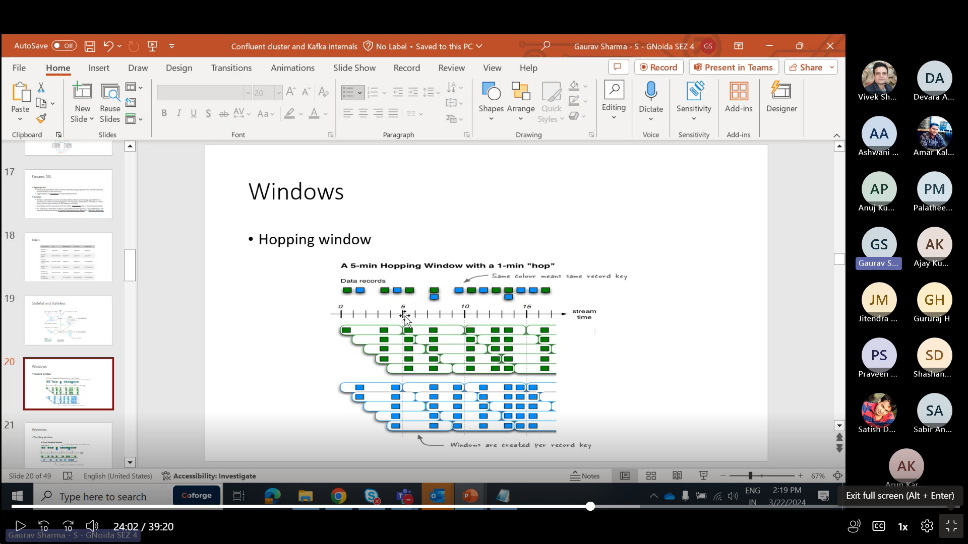

In hopping window 1 min Hop is there i.e window extends after each second.

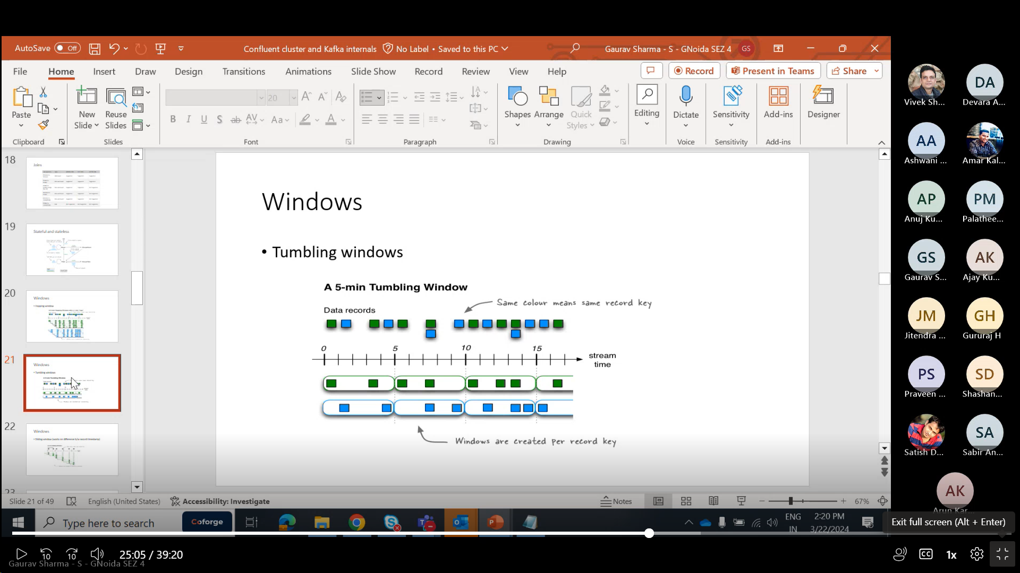

In tumbling window,one window is limited upto 5 min and another window starts after 5 min.

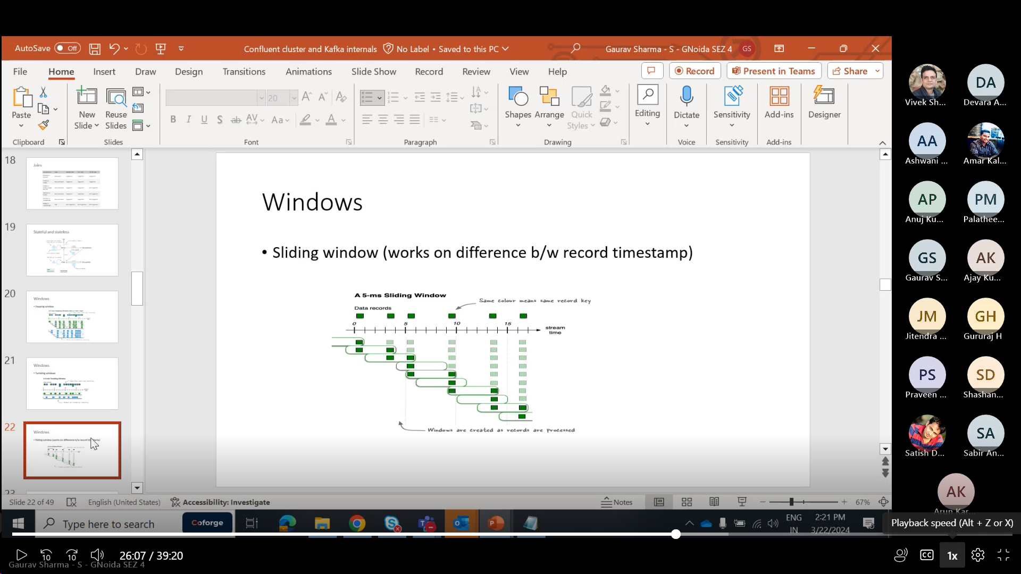

In Sliding window the duration is very small upto 5ms and window keep on sliding in small intervals.

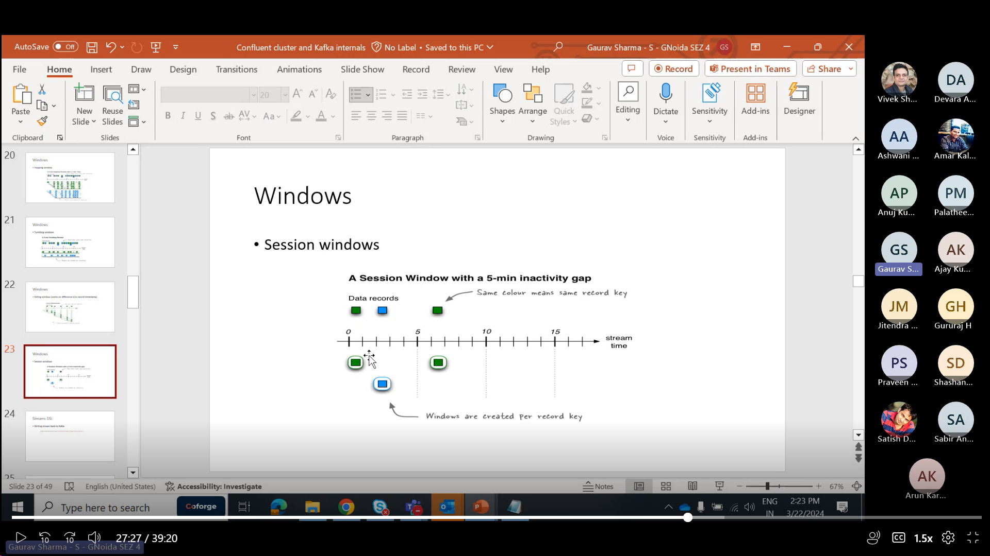

In Session windows,session will timeout due to inactivity for a particular time period.A new session will start after specific time.

Link:- <https://kafka.apache.org/20/documentation/streams/developer-guide/dsl-api.html#creating-source-streams-from-kafka>

KSQLdb:- <https://docs.ksqldb.io/en/latest/developer-guide/ksqldb-reference/>

Why is data co-partitioning required? Because [KStream-KStream](https://kafka.apache.org/20/documentation/streams/developer-guide/dsl-api.html" \l "streams-developer-guide-dsl-joins-kstream-kstream), [KTable-KTable](https://kafka.apache.org/20/documentation/streams/developer-guide/dsl-api.html" \l "streams-developer-guide-dsl-joins-ktable-ktable), and [KStream-KTable](https://kafka.apache.org/20/documentation/streams/developer-guide/dsl-api.html" \l "streams-developer-guide-dsl-joins-kstream-ktable) joins are performed based on the keys of records (e.g., leftRecord.key == rightRecord.key), it is required that the input streams/tables of a join are co-partitioned by key.

Create and verify a topic:

# /usr/local/kafka/bin/kafka-topics.sh --bootstrap-server localhost:9092 -- create --replication-factor 1 --partitions 1 --topic test Created topic "test". # /usr/local/kafka/bin/kafka-topics.sh --bootstrap-server localhost:9092 --describe --topic test

Produce messages to a test topic (use Ctrl-C to stop the producer at any time):

# /usr/local/kafka/bin/kafka-console-producer.sh --bootstrap-server localhost:9092 --topic test

Consume messages from a test topic:

# /usr/local/kafka/bin/kafka-console-consumer.sh --bootstrap-server localhost:9092 --topic test --from-beginning

he appropriate size for a Kafka cluster is determined by several factors. Typically, the size of your cluster will be bound on the following key areas:

• Disk capacity

• Replica capacity per broker

• CPU capacity

• Network capacity

In this configuration, the initLimit is the amount of time to allow followers to con‐ nect with a leader. The syncLimit value limits how long out-of-sync followers can be with the leader.

The servers are specified in the format server.X=hostname:peer Port:leaderPort, with the following parameters

peerPort :The TCP port over which servers in the ensemble communicate with one another

leaderPort: The TCP port over which leader election is performed.

auto.create.topics.enable: it automatically creates the topic in a broker in multiple scenarios .

When a producer starts writing messages to the topic • When a consumer starts reading messages from the topic • When any client requests metadata for the topic

delete.topic.enable :Depending on your environment and data retention guidelines, you may wish to lock down a cluster to prevent arbitrary deletions of topics. Disabling topic deletion can be set by setting this flag to false.

auto.leader.rebalance.enable :In order to ensure a Kafka cluster doesn’t become unbalanced by having all topic leadership on one broker, this config can be specified to ensure leadership is balanced as much as possible. It enables a background thread that checks the distribution of partitions at regular intervals

## Garbage Collector In Apache Kafka

Tuning the Java garbage-collection options for an application has always been some‐ thing of an art, requiring detailed information about how the application uses mem‐ ory and a significant amount of observation and trial and error. Thankfully, this has changed with Java 7 and the introduction of the Garbage-First garbage collector (G1GC). While G1GC was considered unstable initially, it saw marked improvement in JDK8 and JDK11. It is now recommended for Kafka to use G1GC as the default garbage collector. G1GC is designed to automatically adjust to different workloads and provide consistent pause times for garbage collection over the lifetime of the application. It also handles large heap sizes with ease by segmenting the heap into smaller zones and not collecting over the entire heap in each pause. 42 | Chapter 2: Installing Kafka G1GC does all of this with a minimal amount of configuration in normal operation. There are two configuration options for G1GC used to adjust its performance:

1)MaxGCPauseMillis-Garbage collection at regular intervalsd

2)InitiatingHeapOccupancyPercent-This means that G1GC will not start a collection cycle until after 45% of the heap is in use.

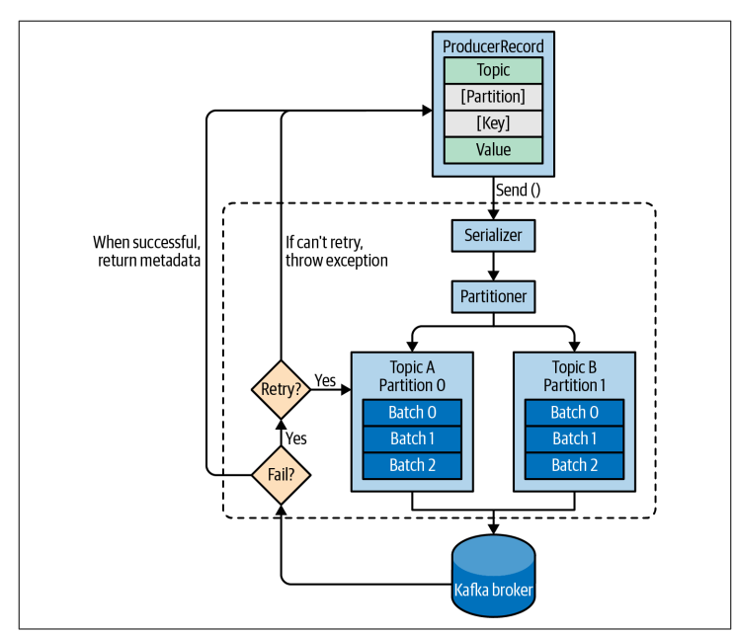

acks=0 The producer will not wait for a reply from the broker before assuming the mes‐ sage was sent successfully. This means that if something goes wrong and the broker does not receive the message, the producer will not know about it, and the message will be lost. However, because the producer is not waiting for any response from the server, it can send messages as fast as the network will support, so this setting can be used to achieve very high throughput.

acks=1 The producer will receive a success response from the broker the moment the leader replica receives the message. If the message can’t be written to the leader (e.g., if the leader crashed and a new leader was not elected yet), the producer will receive an error response and can retry sending the message, avoiding potential loss of data. The message can still get lost if the leader crashes and the latest mes‐ sages were not yet replicated to the new leader.

acks=all The producer will receive a success response from the broker once all in sync replicas receive the message. This is the safest mode since you can make sure more than one broker has the message and that the message will survive even in case of a crash (more information on this in Chapter 6). However, the latency we discussed in the acks=1 case will be even higher, since we will be waiting for more than just one broker to receive the message.

The default produce and consume quotas that are applied to all clients are part of the Kafka broker configuration file. For example, to limit each producer to send no more than 2 MBps on average, add the following configuration to the broker configuration file: quota.producer.default=2M.

To allow clientA to produce 4 MBps and clientB 10 MBps, you can use the following: quota. producer.override="clientA:4M,clientB:10M

# Streams DSL-

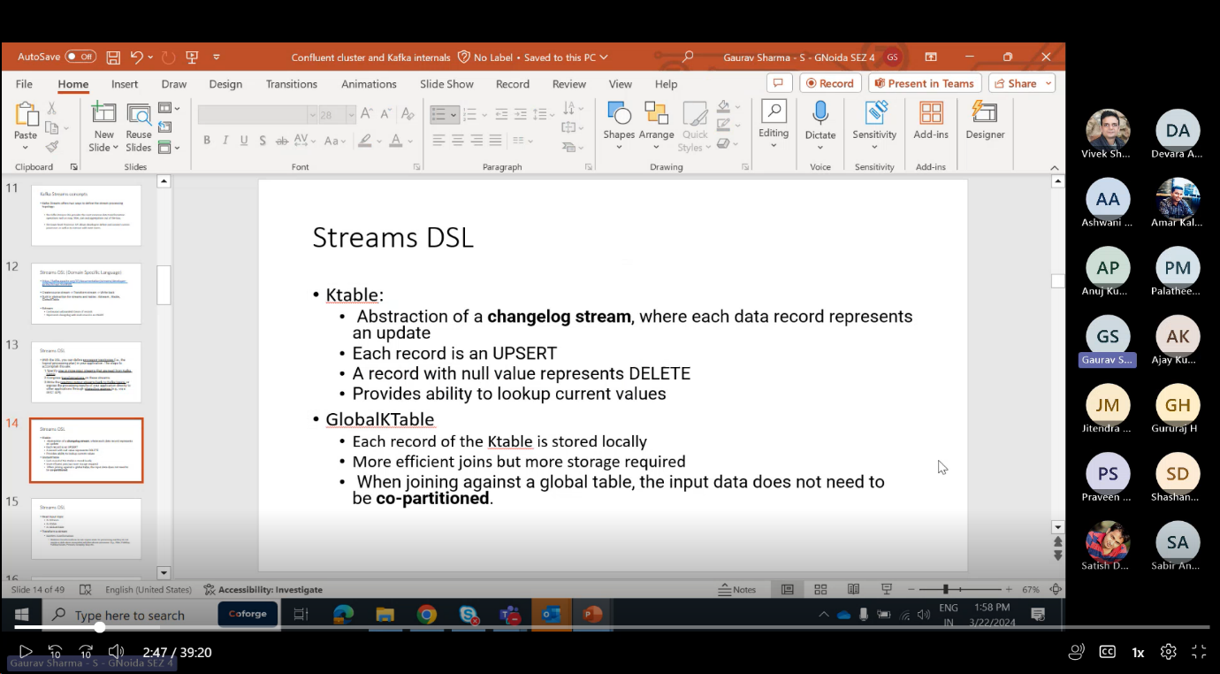KTable-

1)Abstraction of a change log stream,each record represents an update

2)Each record represent upsert.

3)Records with null value represents delete.

GlobalKTable-

1)Each record KTable is stored locally

2)More efficient joins,more storage required.

3)input data need not to be co-partitioned.

4)it is memory intensive.

We can read the topic in many forms KStream🡪topic

KStream → KStream[]

* Branch (or split) a KStream based on the supplied predicates into one or more KStream instances. ([details](https://kafka.apache.org/20/javadoc/org/apache/kafka/streams/kstream/KStream.html#branch-org.apache.kafka.streams.kstream.Predicate...-))
* Predicates are evaluated in order. A record is placed to one and only one output stream on the first match: if the n-th predicate evaluates to true, the record is placed to n-th stream. If no predicate matches, the the record is dropped.

KStream → KStream

* KTable → KTable

Evaluates a boolean function for each element and retains those for which the function returns true. ([KStream details](https://kafka.apache.org/20/javadoc/org/apache/kafka/streams/kstream/KStream.html" \l "filter-org.apache.kafka.streams.kstream.Predicate-), [KTable details](https://kafka.apache.org/20/javadoc/org/apache/kafka/streams/kstream/KTable.html" \l "filter-org.apache.kafka.streams.kstream.Predicate-))

**Grouping vs. Windowing:** A related operation is [windowing](https://kafka.apache.org/20/documentation/streams/developer-guide/dsl-api.html#streams-developer-guide-dsl-windowing), which lets you control how to “sub-group” the grouped records of the same key into so-called windows for stateful operations such as windowed [aggregations](https://kafka.apache.org/20/documentation/streams/developer-guide/dsl-api.html#streams-developer-guide-dsl-aggregating) or windowed [joins](https://kafka.apache.org/20/documentation/streams/developer-guide/dsl-api.html#streams-developer-guide-dsl-joins).

Stateful transformations depend on state for processing inputs and producing outputs and require a [state store](https://kafka.apache.org/20/documentation/streams/architecture.html#streams_architecture_state) associated with the stream processor. For example, in aggregating operations, a windowing state store is used to collect the latest aggregation results per window.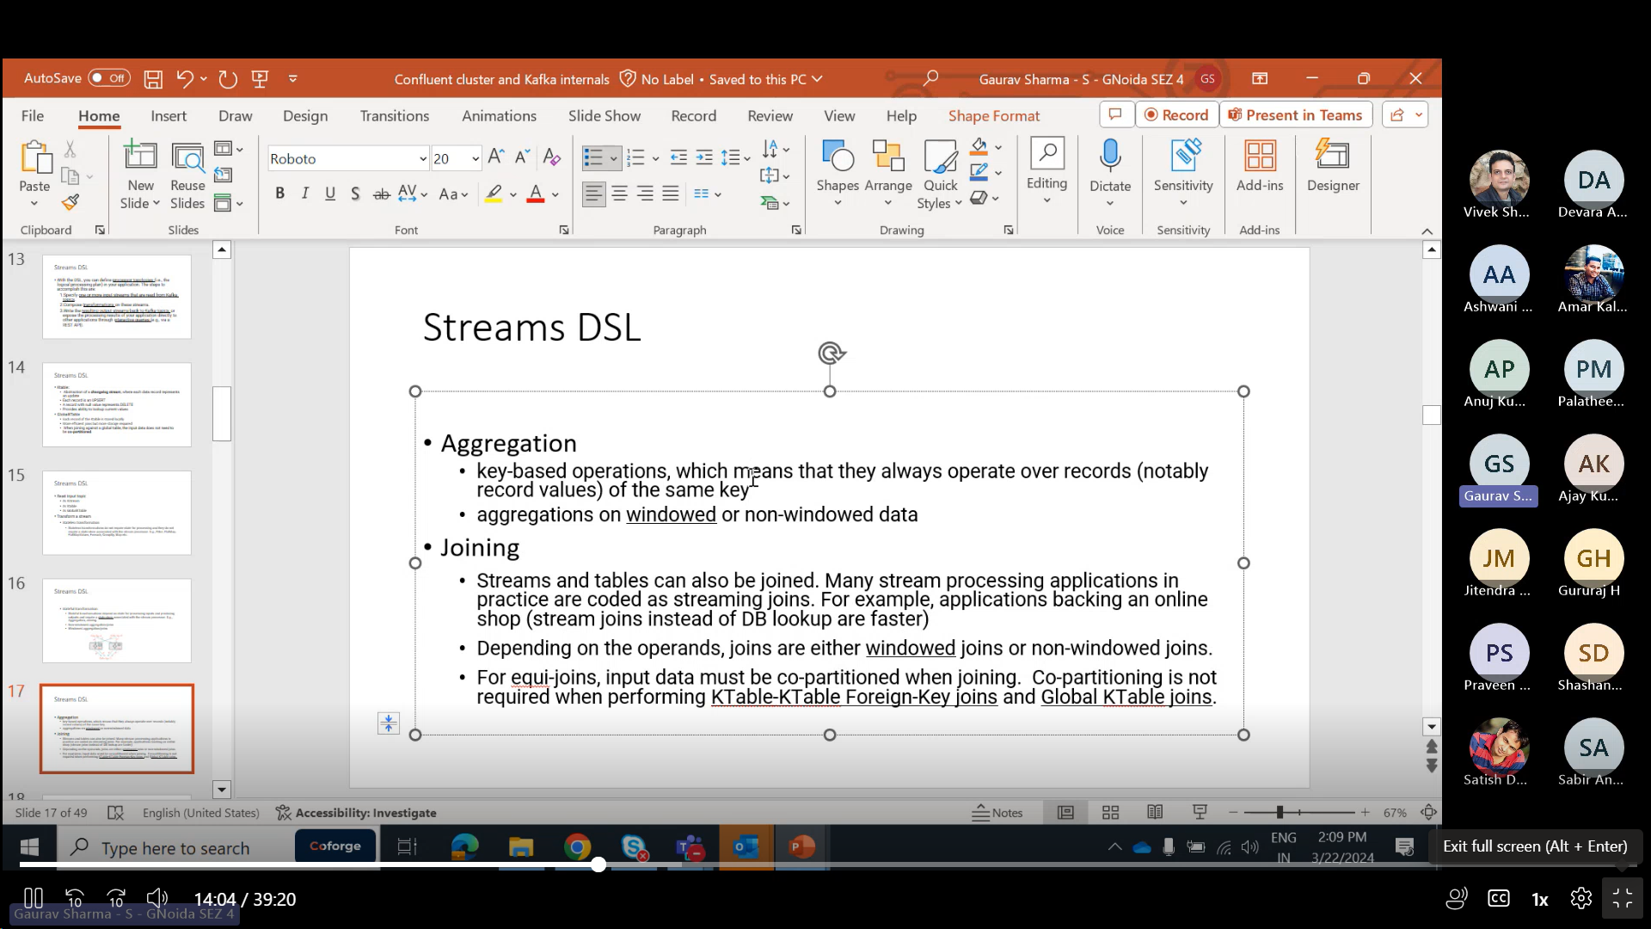

#### [Joining](https://kafka.apache.org/20/documentation/streams/developer-guide/dsl-api.html#id13)

Streams and tables can also be joined. Many stream processing applications in practice are coded as streaming joins. For example, applications backing an online shop might need to access multiple, updating database tables (e.g. sales prices, inventory, customer information) in order to enrich a new data record (e.g. customer transaction) with context information. That is, scenarios where you need to perform table lookups at very large scale and with a low processing latency. Here, a popular pattern is to make the information in the databases available in Kafka through so-called change data capture in combination with [Kafka’s Connect API](https://kafka.apache.org/20/documentation/#connect), and then implementing applications that leverage the Streams API to perform very fast and efficient local joins of such

KStream to KStream applications require Co-Partitioning🡪

Suppose,

Topic A:2 partitions

Topic B:2 Partitions

K1->Topic A::partition 0

K1->Topic B::partition 0

Key 1

And that concept is copartitioning. So let's say we have our two strings from two different topics, so both our topics should have each same number of partitions, OK? And the partition assignment strategy also should be same only then two streams can be joined. Why? Because let's say for example we we are running a stream application, OK and let's say.

Topic.

He has two partitions.

OK, topic B has.

I think we has, let's say again 2 partitions.

So what happens is, you know.

A record with same key, a record with the key will go to same partition all the time. So we are publishing let's say P.

OK, so this record will always go to same partition message when goes to partition.

Zero.

So this also has to go to partition 0. Why? Because because what happens is whenever we are running the stream application, right? So let's say two tasks are created, 2 instances are created internally it will it will just create the task OK and each task will handle one partition. So these ports should go to same task only then join can happen. OK so keep is joined right? So we need to have the same keys available to the same task.

And then only it can do a join and it can also.

Store it in the local state stores OK state store will contain the local state of the. It will contain the state of the stream. OK, so that means it it needs to have the key same keys all the time. OK.

And so partition, number of partition and partition assignment strategy has to be same for both the topics. So that means case into K string requires 4 partitioned topics.

KStream To KStream require Co-partitioned topics.

Security Protocol-

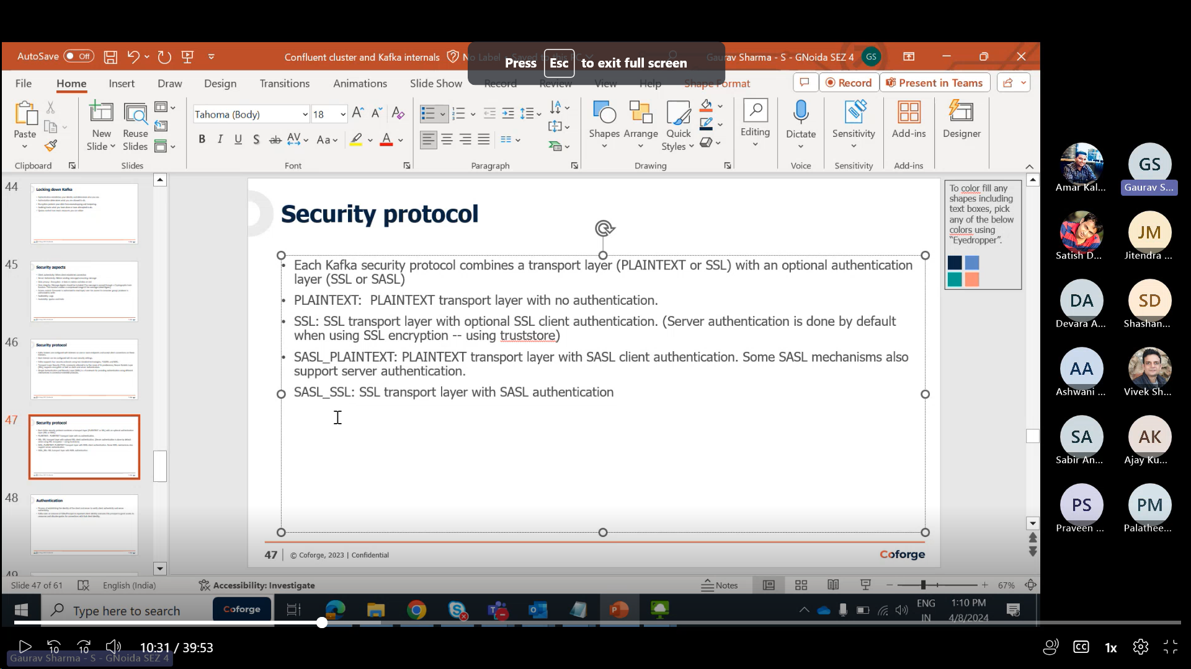

SASL\_SSL means we are doing authentication using SASL and encryption using SSL i.e .

Kafka Uses principal of authorisation ,access and authencity ,we are proving Principal In Kerberos.

OK, so let's say you are using sasl SSL.

Gaurav Sharma - S - GNoida SEZ 4 15 minutes

OK, in this case what happens is you're authentication is happening with sassel.

Gaurav Sharma - S - GNoida SEZ 4 15 minutes 5 seconds

OK.

Gaurav Sharma - S - GNoida SEZ 4 15 minutes 6 seconds

But there will be server authentication happening with SSL because whenever we want to send any message or we want to consume a new message we have to do the encryption OK and by default as I said we'll do the server AUTHENTICATION OK and only then it will get the keys for encryption OK whenever we are using security protocol so system and making client authentication as required.

Gaurav Sharma - S - GNoida SEZ 4 15 minutes 33 seconds

OK, that time both are authentication as well as encryption will happen using SSL.

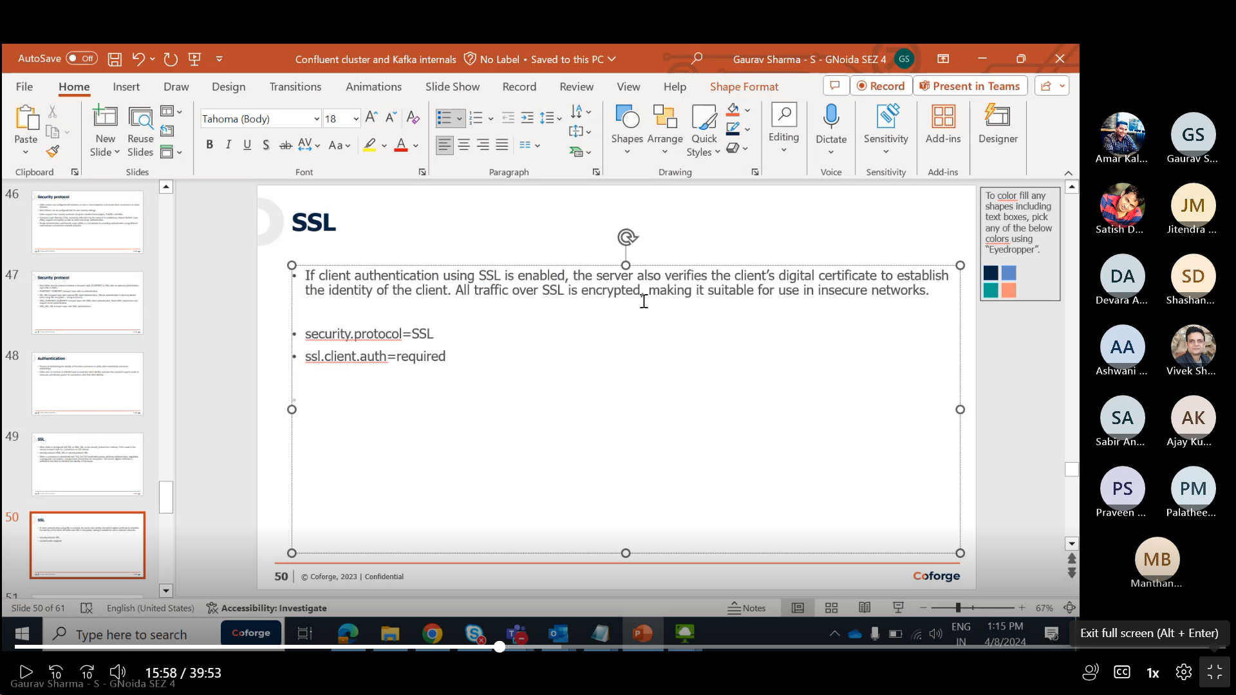

SSLtruststorelocation:it is file stored in specific location.it is used to authenticate the server.

If we set ssl.client.auth=required as in pic abov then we also have to maintain keystore to authenticate client.broker will request client for authentication and for that we have to maintain Keystore.

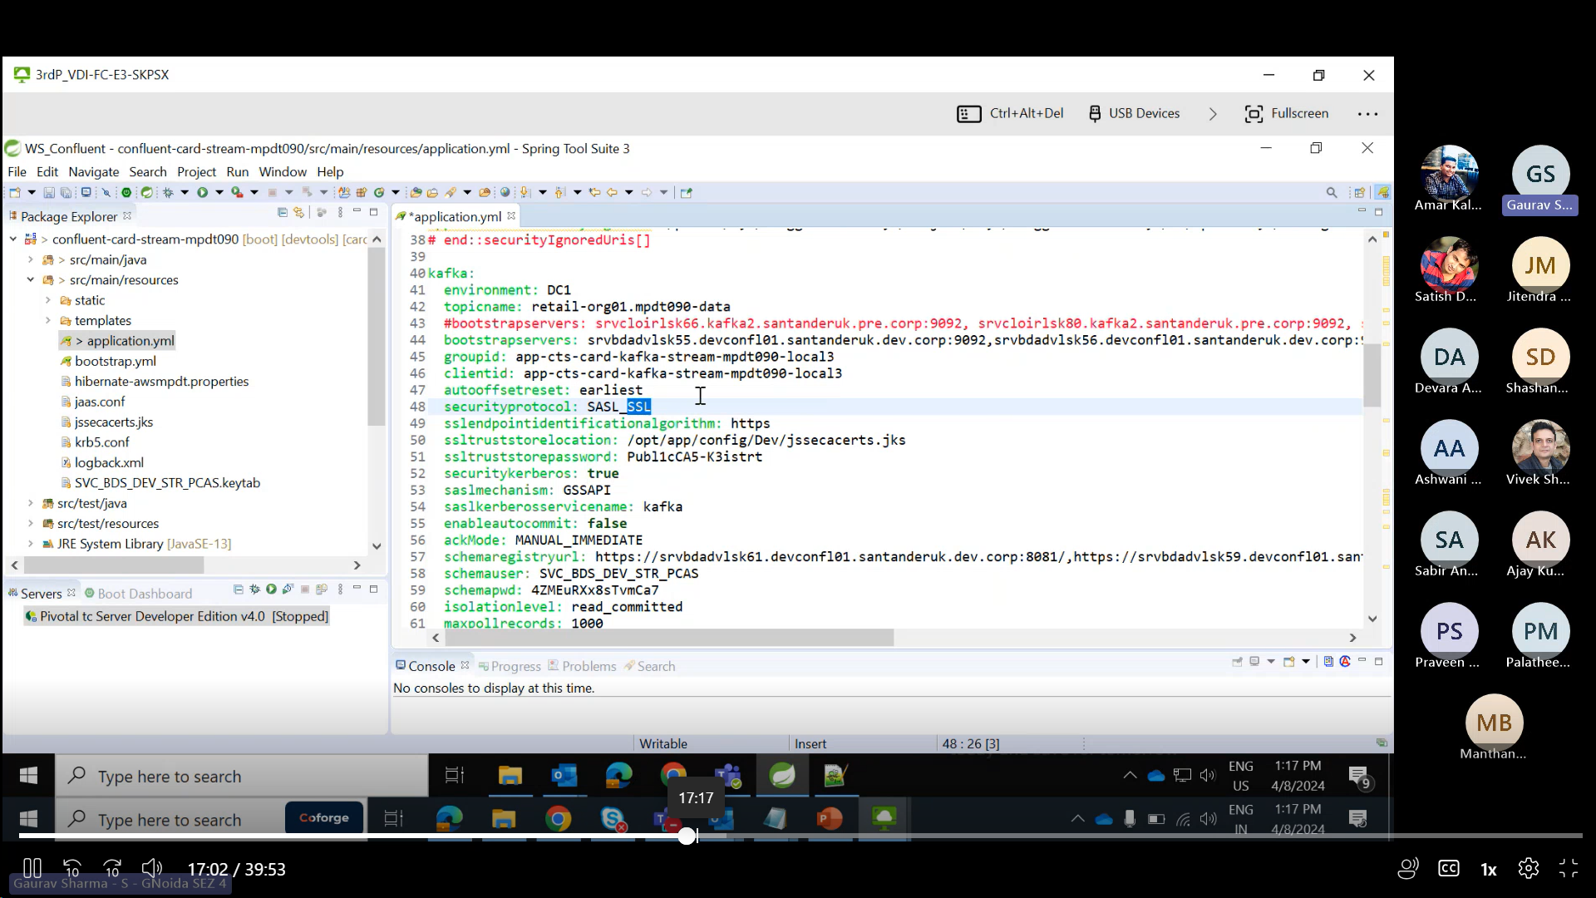

For SASL\_SSL,no client authentication,client authentication is for SaSl only .

# KStream to KStream joins-

Meaning that all tuples close to each other with regard to time are joined.Time here is difference to size of window.

These joins are always windowed joins because otherwise, the size of the internal state store used to perform the join would grow indefinitely.

KStream-KStream Join is always windowed joins, we must provide a join window.

KStream<String, String> joined = left.join(right,

(leftValue, rightValue) -> "left=" + leftValue + ", right=" + rightValue, /\* ValueJoiner \*/

JoinWindows.of(TimeUnit.MINUTES.toMillis(5)),

Serdes.String(), /\* key \*/

Serdes.Long(), /\* left value \*/

Serdes.Double() /\* right value \*/

);

## KTable to KTable Joins-

Are designed to consistent with their counterparts in relational databases. they are always non-windowed joins.

The changelog streams of KTables is materialized into local state stores that represent the latest snapshot of their tables. The join result is a new KTable representing changelog stream of the join operation.

The join here is key-based — that is, leftRecord.key == rightRecord.key — and will be automatically triggered everytime a new input is received.

KTable<String, String> joined = left.join(right,

(leftValue, rightValue) -> "left=" + leftValue + ", right=" + rightValue /\* ValueJoiner \*/

);

## KSTREAM to KTABLE joins-

They allow you to perform table lookups against a KTable everytime a new record is received from the KStream.

The KTable lookup is always done on the current state of the KTable; thus, out-of-order records can yield a non-deterministic result. The result of a KStream-KTable join is a KStream.

KStream<String, String> joined = left.join(right,

(leftValue, rightValue) -> "left=" + leftValue + ", right=" + rightValue, /\* ValueJoiner \*/

Serdes.String(), /\* key \*/

Serdes.Long() /\* left value \*/

);

SASL (Simple Authentication Security Layer) is a framework that provides developers of applications and shared libraries with mechanisms for authentication, data integrity-checking, and encryption.

* [SASL using JAAS](https://docs.confluent.io/platform/current/kafka/authentication_sasl/index.html#kafka-sasl-auth)

Kafka uses the Java Authentication and Authorization Service (JAAS) for SASL configuration. You must provide JAAS configurations for all SASL authentication mechanisms. This topic explains how to configure JAAS for SASL.

* [SASL/GSSAPI (Kerberos)](https://docs.confluent.io/platform/current/kafka/authentication_sasl/authentication_sasl_gssapi.html#kafka-sasl-auth-gssapi)

SASL/GSSAPI uses your Kerberos or Active Directory server for authentication.

* [SASL/OAUTHBEARER](https://docs.confluent.io/platform/current/kafka/authentication_sasl/authentication_sasl_oauth.html#cp-oauth-authentication)

Only suitable for use in non-production Kafka installations, SASL/OAUTHBEARER enables the use the OAuth 2 Authorization framework in a SASL context to create and validate unsecured JSON web tokens for authentication.

* [SASL/PLAIN](https://docs.confluent.io/platform/current/kafka/authentication_sasl/authentication_sasl_plain.html#kafka-sasl-auth-plain)

SASL/PLAIN uses a simple username and password for authentication.

* [SASL/SCRAM](https://docs.confluent.io/platform/current/kafka/authentication_sasl/authentication_sasl_scram.html#kafka-sasl-auth-scram)

SASL/SCRAM uses usernames and passwords stored in ZooKeeper. Credentials are created during installation.

BufferExhaustedException:-

This exception is thrown if the producer cannot allocate memory for a record within max.block.ms due to the buffer being too full. In earlier versions a TimeoutException was thrown instead of this.

12. Consumer failed to process record # 10 and succeeded in processing record # 11. Select the course of action that you should choose to guarantee at least once processing

b) Do not commit until successfully processing the record at offset 10

You have a Zookeeper cluster that needs to be able to withstand the loss of 2 servers and still be able to function. What size should your Zookeeper cluster have?

1. 2 b) 5 c) 4 d) 6 e) 3

If any two servers fail, the ensemble can still function because a quorum can be formed out of the remaining three nodes. Thus, a five-node ZooKeeper ensemble can tolerate failure of up to two nodes.

Q=2N+1

Q=quorum

N=number of server failure that is needed to be handled.

rule "same key goes to the same partition" is true unless b) the number of partition changes

The rule "same key goes to the same partition" is true unless... Increasing the number of partition causes new messages keys to get hashed differently, and breaks the guarantee "same keys goes to the same partition". Kafka logs are immutable and the previous messages are not re-shuffled.

24.) To read data from a topic, the following configuration is needed for the consumers

a) any broker to connect to, and the topic name

### **auto.leader.rebalance.enable-**

means leader rebalance will automatically happen if leader is unstable. Enables auto leader balancing. A background thread checks the distribution of partition leaders at regular intervals, configurable by leader.imbalance.check.interval.seconds. If the leader imbalance exceeds leader.imbalance.per.broker.percentage, leader rebalance to the preferred leader for partitions is triggered.

26)A producer is sending messages with null key to a topic with 6 partitions using the DefaultPartitioner. Where will the messages be stored?

1) Any of the topic partitions

27)A consumer sends a request to commit offset 2000. There is a temporary communication problem, so the broker never gets the request and therefore never responds. Meanwhile, the consumer processed another batch and successfully committed offset 3000. What should you do?

Nothing, , it is displaying the same message.In the case of rebalance, this will cause more duplicates.

32. The Controller is a broker that is... (select two)

a) elected by broker majority

b) is responsible for consumer group rebalances

c) is responsible for partition leader election

d) elected by Zookeeper ensemble

c,d

34. Your priority for producing messages to the Kafka cluster is maximum throughput over low

latency. What would you do to accomplish this? (choose one)

a. Set batch.size low value and linger.ms to 0

b. Set batch.size high value and linger.ms to 0

c. Set batch.size low value and linger.ms to high value

d. Set batch.size high value and linger.ms to high value

d)The throughput is records processed per second,Latency is wait time befor process starts.

35. Your Kafka cluster consists of 3 brokers. You have 4 producer clients sending messages to the

“driver” topic which currently has 12 partitions and the related produce requests are receiving

timeout exceptions. What would you do to reduce these exceptions? (choose one)

Ans)TimeoutException comes when particular broker is overloaded with records ,so we need

another brokers to work upon it.

Use of Kafka Connectors

Connectors and tasks are logical units of work that run as a process. The process is called a worker in Kafka Connect. There are two modes for running workers:

* **Standalone mode**: Useful for development and testing Kafka Connect on a local machine. It can also be used for environments that typically use single agents (for example, sending web server logs to Kafka).
* **Distributed mode**: Distributed mode is recommended for production environments because of scalability, high availability, and management benefits. It runs Connect workers on multiple machines (nodes), which form a Connect cluster. Kafka Connect distributes running connectors across the cluster. You can add or remove nodes as your needs evolve.

59. There are five brokers in a cluster, a topic with 10 partitions and replication factor of 3, and a quota of producer\_bytes\_rate of 1 MB/sec has been specified for the client. What is the maximum throughput allowed for the client?

a) 0.33 MB/s

b) 5 MB/s

c) 10 MB/s

d) 1 MB/s

b) Each producer is allowed to produce @ 1MB/s to a broker. Max throughput 5 \* 1MB, because we have 5 brokers.

A Zookeeper configuration has tickTime of 2000, initLimit of 20 and syncLimit of 5. What's the timeout value for followers to connect to Zookeeper?

**A**20 sec

**B**10 sec

**C**2000 ms

**D**40 sec

tick time is 2000 ms, and initLimit is the config taken into account when establishing a connection to Zookeeper, so the answer is 2000 \* 20 = 40000 ms = 40s

What's a Kafka partition made of?

**A**One file and one index

**B**One file

**C**One file and two indexes per segment

**D**One file and two indexes

Kafka partitions are made of segments (usually each segment is 1GB), and each segment has two corresponding indexes (offset index and time index)

**Tick-Time**: used by zookeper to do heartbeats. session timeout is double the TickTime.

**initLimit**: is timeouts that zookeeper, used to limit the time that Zookeeper servers which are already in quorum have to connect to a leader.

 entry **syncLimit** limits how far out of date a server can be from a leader.

* **tickTime** : the basic time unit in milliseconds used by ZooKeeper. It is used to do heartbeats and the minimum session timeout will be twice the tickTime.
* **dataDir** : the location to store the in-memory database snapshots and, unless specified otherwise, the transaction log of updates to the database.
* **clientPort** : the port to listen for client connections

## KSQLDB:-

Allows you to build stream processing applications using Apache Kafka with ease of building traditional applications on a relational database. Using SQL to define what you want to do rather than how, it is easy to build kafka-native apps for real time data,

ksqlDB is designed from the principle of simplicity. While many streaming architectures require a grab-bag of components pieced together from many projects, ksqlDB provides a single platform on which you can build streaming ETL and streaming applications, and all with just a single dependency—Apache Kafka.

Regardless of how we choose to store it later, much of the data that we work with in our systems begins life as part of an **unbounded event stream.**

Stream processing is a method of processing events in an event stream, as they are happening. It is distinct from batch processing, in which events are processed at some delayed point in time, after they are created. With stream processing, we can react to events happening in the real world when they occur, rather than afterwards.

With ksqlDB, we can apply this concept of stream processing using SQL. The ability to use SQL, unlike other options that require complex coding to perform even simple tasks, makes stream processing accessible to many more developers and analysts.

SELECT \*

FROM WIDGETS

WHERE WEIGHT\_G > 120

ksqlDB separates its distributed compute layer from its distributed storage layer, for which it uses Apache Kafka.

**ksqlDB allows us to read, filter, transform, or otherwise process streams and tables of events, which are backed by Kafka topics. We can also join streams and/or tables to meet the needs of our application. And we can do all of this using familiar SQL syntax**.

## Interacting with KSQLDB:-

## There are several ways to interact with ksqlDB, including a command line interface, a web UI, a REST API, and client libraries for Java and other languages.

## CLI:-

The ksqlDB CLI is very similar in look and feel to command line tools for relational databases that you may be familiar with, such as Postgres’s psql or Oracle’s SQL\*Plus:

## REST API:-

The [ksqlDB REST API](https://docs.ksqldb.io/en/latest/developer-guide/ksqldb-rest-api/" \t "_blank) provides programmatic access to ksqlDB for managing objects

Create Stream using ksqlDB cloud:-

CREATE STREAM MOVEMENTS (PERSON VARCHAR KEY, LOCATION VARCHAR)

WITH (VALUE\_FORMAT='JSON', PARTITIONS=1, KAFKA\_TOPIC='movements');

INSERT INTO MOVEMENTS VALUES ('Allison', 'Denver');

INSERT INTO MOVEMENTS VALUES ('Robin', 'Leeds');

INSERT INTO MOVEMENTS VALUES ('Robin', 'Ilkley');

INSERT INTO MOVEMENTS VALUES ('Allison', 'Boulder');

A company configured a Kafka cluster with the parameters  --log.retention.hours = 200,  --log.retention.minutes = 200 and --log.retention.ms = 200. With this configuration, how long will log data be retained before old log segments will be discarded to free up space?

1)200 MS.

If more than one similar config is specified, the **smaller unit size will take precedence**.

**log.retention.ms:** The number of milliseconds to keep a log file before deleting it (in milliseconds), If not set, the value in log.retention.minutes is used. If set to -1, no time limit is applied.

In case the consumer has the wrong leader of a partition, it will issue a **metadata request**. The Metadata request can be handled by any node, so clients know afterwards which broker are the designated leader for the topic partitions.

The response contains metadata for each partition, with partitions grouped together by topic:

- **Leader:** The node id of the Kafka broker currently acting as leader for this partition. If no leader exists because we are in the middle of a leader election this id will be -1.

- **Replicas:** The set of alive nodes that currently acts as slaves for the leader for this partition.

- **ISR:** The set subset of the replicas that are "caught up" to the leader.

- **Broker:** The node id, hostname, and port information for a Kafka broker.

**Note:** Produce and consume requests can only be sent to the node hosting **partition leader**.

ksqlDB has a limitation in that it **doesn't support structured keys**, preventing the creation of a stream from a windowed aggregate.

In practical scenarios, when working with windowed aggregates in ksqlDB, understanding the limitations related to structured keys is important for designing and implementing effective streaming applications.

Using ksqlDB, which of the following two options together allow you to use Avro data and integrate with Confluent Schema Registry?

To be able to use Avro data and integrate with Confluent Schema Registry you need to do the following two steps:

- Install the Confluent Schema Registry. This is included by default with Confluent Platform.

- Configure the ksql.schema.registry.url property in the ksqlDB server configuration to point to Schema Registry.

**Important Note:** Avro message values are supported. Avro keys are not yet supported.

In Kafka, the purpose of **describing** topics is to know the leader for the topic, the broker instances acting as replicas for the topic, and the number of partitions of a Kafka topic that has been created with.

When describing Kafka topics you can set some additional properties to only show specific topics / partitions, e. g.:

**--topics-with-overrides:** If set when describing topics, only show topics that have overridden configs.

**--unavailable-partitions:** If set when describing topics, only show partitions whose **leader is not available**.

**--under-min-isr-partitions:** If set when describing topics, only show partitions whose ISR count is less than the configured minimum.

**--under-replicated-partitions:** If set when describing topics, only show under replicated partitions.

To make your data fault-tolerant and highly-available, every Kafka topic can be **replicated**, so that there are always multiple brokers that have a copy of the data just in case things go wrong, you want to do maintenance on the brokers, and so on. A common production setting is a **replication factor of 3**, i. e., there will always be three copies of your data. This replication is performed at the level of topic-partitions.

If the replication factor is **4**, three brokers can be down (**replication factor - 1**) without impacting the topic availability.

At-least once guarantee means you will definitely receive and process every message, but you may process some messages additional times in the face of a failure.

For a consumer application **at-least once processing** means the consumer group receives a batch of messages from Kafka, transforms these and writes the results to a database. The consumer application has enable.auto.commit set to false and is programmed to commit their offsets back to Kafka **once the database write succeeds**. If the consumer fails after writing the data to the database but before saving the offsets back to Kafka, it will reprocess the same records next time it runs and save them to the **database once more**.

## KSQLDB:-

To configure ksqlDB to connect to a Kafka cluster over SSL with a user-supplied trust store, you set **security.protocol** to **SSL** and provide the trust store location and password.

To note:

* **ksqlDB can connect to an Apache Kafka cluster over TLS**
* **ksqlDB can connect to an Apache Kafka cluster over TLS and authenticate using SASL**
* **ksqlDB will work with an Apache Kafka cluster secured using Kafka ACLs**
* **ksqlDB will work with a HTTPS Confluent Schema Registry**
* **ksqlDB will work with Confluent Cloud**